A
CKNOWLEDGING A VOCATION
Every Christian vocation is born within and for the Church, at the service of the world. For this reason, many lay people who feel called to the Marist vocation tend to seek recognition from the ecclesial community.

In general, bonding is acknowledged by those who assume the responsibility of leading the lay Association. Bonding to the charism comes about thanks to the mediation of the Association’s leaders. Choosing to live the Marist charism implies becoming part of an established group, which acknowledges and welcomes the person in its midst. The Provincial could initially be in charge of acknowledging and accepting the person’s Marist option, but eventually the lay leaders of the Association should assume this responsibility.

If we thought about a structure or Association in which brothers and lay people could participate together, recognition would come from that same institution. The Constitutions should consider this, since the fact would have implications for the brothers.
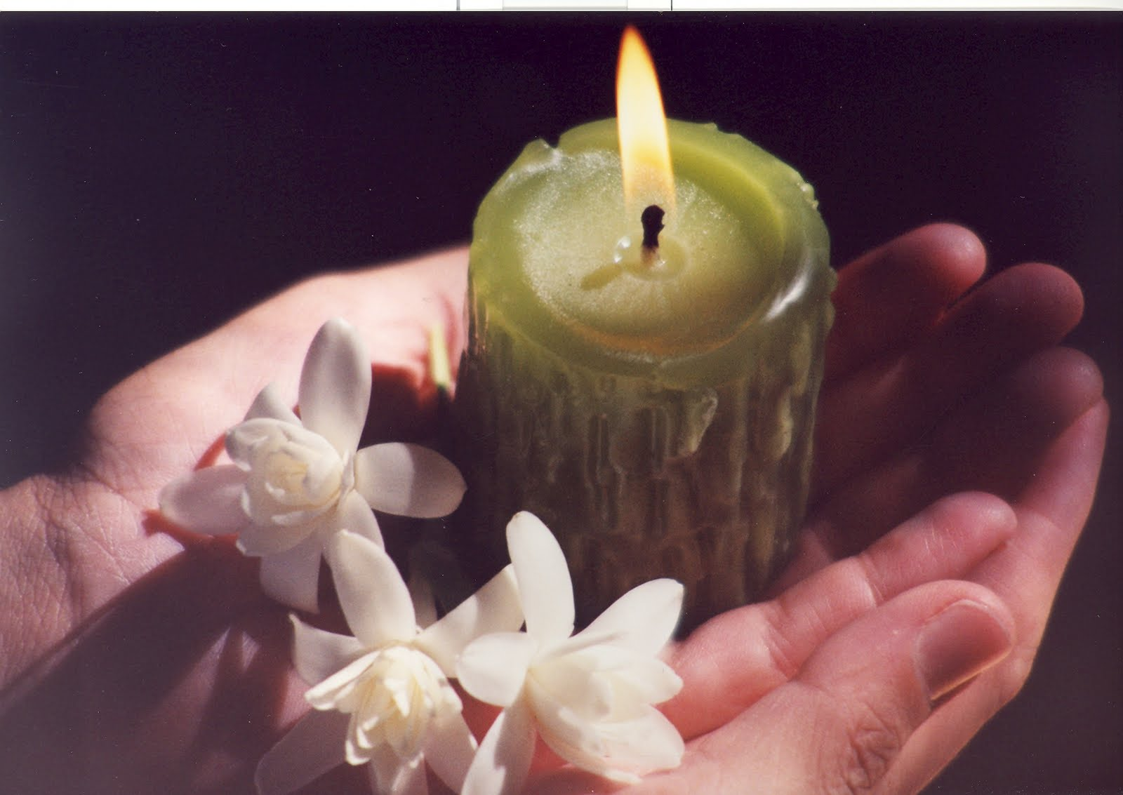

In principle, from a vocational perspective, bonding should be an option for life. Duties towards the Association, and mission commitments could be temporary.

It would be important to renew the bond from time to time. Our response to God’s call is always developing and we confirm it periodically throughout life. Renewing the bond year after year, for example, can help us recreate and strengthen our commitment. However, a deep and stable option is more important than its time framework.

Cf. GAST 140.
Religious Institutes present a variety of options in this regard. The Signum Fidei Fraternity and the Lasallian Fraternity are two groups institutionally recognized as “associated”, “in organic relationship with the FSC Institute”. Currently neither of them has an ecclesial recognition as private or public Association of the Faithful. The Christian Life Community (CLC) follows an Ignatian Spirituality. It traces its origins to the Marian Congregations. It is autonomous vis-à-vis the Company of Jesus regarding decision-making processes, although they are in close collaboration with the Jesuits. It became an international Public Association of the Faithful in 1990. The Association of Salesian Cooperators participates in the spirituality of the Salesian Society. It has canonical personality as international Public Association of the Faithful. Being in organic relation to a religious institute, their Regulations are approved by the Salesian Congregation, not the Pontifical Council for the Laity. The Lay Marianists Communities are part of the Marianist Family. In 2000, they became an international Private Association of the Faithful. The Viatorian Associates are individual lay partners (not groups) officially recognized by the Constitutions of the Clerics of Saint Viator. They are part of the religious communities as “full members”, but without being religious. The Clerics of Saint Viator are gradually moving from a religious community with lay associates to the new model of Viatorian Community, in which religious and lay members participate in equal terms according to their own vocation and identity.
The Church recommends starting with a temporary bond, renewed annually for at least 4 years. An option for life could come later, or we could use the same system as the Daughters of Charity, for example: a definitive link, which decays if it is not renewed annually.

