F
AMILY SPIRIT
The home at Nazareth is the model for our family spirit, which consists of love and forgiveness, support and help, forgetfulness of self, openness to others, and joy.

Marcellin taught us how to make a family. His letters constantly show it: “I did not forget to tell the brothers how much I love them and how much I suffer for not being with them.”

Like our first communities, we feel inspired by the home of Nazareth to develop our attitudes that make our family spirit, which consists of love and forgiveness, support and help, forgetfulness of self, openness to others, and joy.
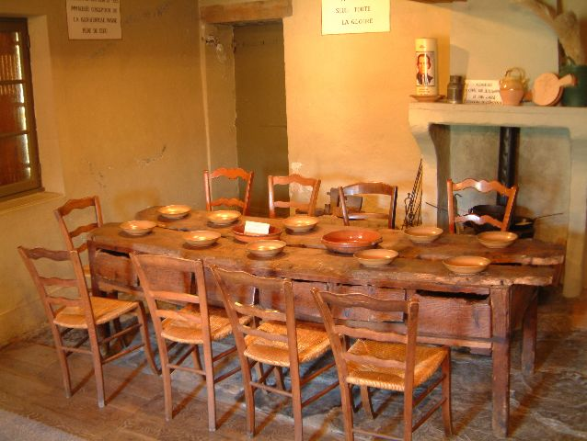
It is the characteristic of our charism that, from the beginning, most attracts people in the first place and which singles us out. It is our great prophetic sign. In the different ways of living together, we, lay people and brothers, can update this family spirit. It is reflected on trust, acceptance and the ability to be unsophisticated.

All of this helps us to make the “Church of the apron” come true, without any hierarchies. We all share what we have and there are no teachers among us. Many times, a shared housework helps us understand the greatness of living with “marvelous companions.”

Some characteristics that an environment of a Marist family can have are:
- a space of welcoming, without judging, where no one is condemned,
- a place with simple and authentic communication,
- a warm space of tenderness where weakness is an opportunity to show and feel unconditional love,
- a “house” where one can walk in “house shoes”, with familiarity,
- a space to share and express our faith
- a place which has the horizon of Marist life and mission in the Church and in the world

Cf. Constitutions 6
Cf. Water from the Rock, 30
Cf. Gathered Around the Same Table 68
Cf. Emili Turú in He gave us the name of Mary.

