EMPOWER THOSE WHO HAVE NO VOICES
Day of General Discussion 2018: “Protecting and empowering children as human rights defenders”

- Message of Luis Pedernera, member of the Committee on the Rights of the Child (CRC)

On 28 September 2018, the United Nations Committee for the Rights of the Child (“the Committee”) will celebrate the Day of General Discussion with the theme Protecting and Empowering Children and Adolescents as Human Rights Defenders.
The Committee and Child Rights Connect have been working towards this day by gathering individuals, organisations and boys, girls and adolescents from different parts of the world to give their reports.
In this context, I welcome the initiative of the Marist International Solidarity Foundation – FMSI which, by mobilizing and raising awareness about human rights to children from different regions, bring us this valuable document where they give us their opinions.
You will find here the stories of children and adolescents who have assumed the role of defenders of human rights, what helps them act as such, what are the barriers and risks that they face when they defend their rights, how to protect them and how adults can assist them to effectively assume the role of defenders of their rights. In 2018 we are celebrating 20 years of the Universal Declaration of Human Rights which was approved by the General Assembly in 1998. It is quite significant that today we deepen our understanding of how children work and strive for their human rights, what they mean and how they are lived.
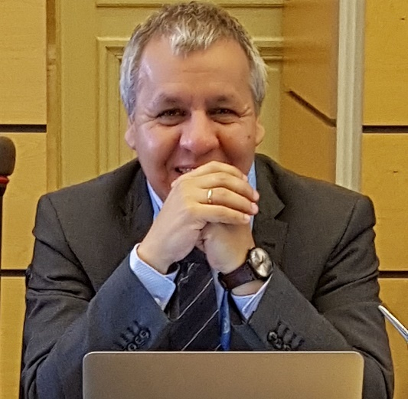
The upcoming meeting in the city of Geneva allows us to establish strong ties/allegiances/connections with the United Nations Rapporteur of Defenders of Human Rights and other people who work for the human rights around the world. The objectives that we have drawn together/proposed for the day are included in the conceptual note of the day of general discussion. We want to highlight the promotion of a global movement of children as defenders of Human Rights which includes their roles as protagonists in partnership with the States, the national institutions for human rights, the United Nations, civil society and the private sector with a view to increasing awareness and understanding about the following points:
- The definition of children and adolescents as defenders of human rights, their role and activities;
- The situation, experience and point of view of children and adolescents as defenders of human rights;
- The gaps between international, regional and Human Rights laws regarding the protection and empowerment of children and adolescents as human rights defenders;
- The obligations of the States related to the protection and empowerment of children and adolescents who act or who wish to act as human rights defenders;
- Finally, the roles and responsibilities of adults in relation to the protections and empowerment of children and adolescents who are who want to be human rights defenders.
Many expectations have been places on this new Day of General Discussion which, without doubt, will gather fundamental contributions to the actions that will be taken within/about/resulting from this theme/concept. It is a novelty in the field of children’s rights that adults and children discuss our experience in this area.
And, without fear of being wrong, and as this important document reflects, it is the <<new ideas, creative ways to call attention to the problems>> that will enhance the debate. <<Every child has a unique story and unique experiences. This is the advantage of the children.>>
Luis Pedernera
- PRESENTATION:
Marist International Solidarity Foundation (FMSI) is an international organization initiated by the Marist Brothers and present in 80 countries. FMSI has more than 10 years of experience working in the field of international solidarity, supporting the promotion and defense of children's rights in the world, especially in the field of education. It works at the international level, participating in the mechanisms of the United Nations and in collaboration with other organizations with similar interests. Since 2011 it has been accredited by ECOSOC, and holds special consultative status with the United Nations and engages with UN processes to advocate for children’s rights.
FMSI participated in the Day of General Discussion, a global discussion focusing on children as human rights defenders. Its main goal was to bring together a global movement to protect and empower children as human rights defenders.
The fourth call of the XXII Marist General Chapter (2017) invites us "to journey with children and young people living on the margins of life.” Specifically, it asks us to "empower those who have no voice, avoiding any paternalism.” This intention was behind Marist participation in the United Nations's Day of General Discussion, 2018.
1,652 Marist children from 12 countries reflected on and discussed about their role as human rights defenders, as well as questions around both the opportunities and necessary supports that could help them face the difficulties, and challenges involved in assuming this role. FMSI coordinated the consultation among local Marist partners in 12 countries: the Philippines, Australia, Madagascar, Paraguay, Chile, Argentina, Brazil, Mexico, Canada, Portugal, Colombia and Spain. Also, it carried out a workshop with young adults in the USA.
A significant proportion of the respondents study in private Marist schools, but many also come from disadvantaged areas, whether urban or rural. Several have parents who are either immigrants or incarcerated, and others suffer various types of violence. They are also assisted by Marist social projects.

- WHAT ARE THE DAYS OF GENERAL DISCUSSION? (Child Right’s Connect)
The United Nations Committee on the Rights of the Child is a group of 18 experts from all over the world that gives advice to governments about how to keep the promises they made to children under the Convention on the Rights of the Child.
The UN Committee on the Rights of the Child holds general discussions on one specific article of the Convention or related subjects. The purpose of such Days of General Discussion (DGD) is to foster a deeper understanding of the contents and implications of the Convention as they relate to specific topics.
The DGD is a one day meeting which takes place in Palais des Nations, in Geneva, Switzerland. However, the DGD is much more than just a meeting and can be a unique opportunity to engage stakeholders, including children, around a specific topic through worldwide consultations.
The Committee makes sure that children’s views are part of the discussion. It does this by talking to children across the world before the DGD, making sure that children take part in the discussions on the day itself and keeps them informed and involved afterwards.

- WHO ARE HUMAN RIGHTS DEFENDERS? (Child Right’s Connect)
Human rights defenders are people who take action to defend their own rights or those of others.
One famous example is Malala Yousafzai who has advocated for girls’ right to education in Pakistan and now defends the right to education all over the world.
It is generally only adults who are called ‘human rights defenders’ while children are instead called things like ‘civic actors’ or ‘agents’.
Often children don’t appear in documents that set out protections for human rights defenders. This is in spite of the fact that children can face extra challenges when they act as human rights defenders. These include: the inability to access information as easily as adults; laws that stop them from joining or setting up their own groups; adults that don’t take them seriously and limit or prevent their involvement.

- CONSULTATION METHODS
The Committee is in charge of the event but Child Right’s Connect is the organization that works with many other children’s organisations to prepare everything and make the DGD happen.
Child Right’s Connect worked with the Centre for Children’s Rights at Queen’s University, Belfast, and with an international advisory group of children to establish methods of engagement for the consultation.
Some of the things that were discussed include:
- The role that children can and do play as human rights defenders.
- What helps children to act as human rights defenders.
- What the barriers are and what risks children face.
- How to protect children human rights defenders.
- How children can be supported by adults to act as human rights defenders.
- Questions about the role of business, the media, and social media
- Additional advice for the Committee.
- SUMMARY TABLE OF CONSULTATIONS:

Country | Cities | # of Children Consulted
PHILLIPINES | General Santos City, Koronadal City | 45
SPAIN | Huelva | 35
BRAZIL | Federal District, Minas Gerais, Paraíba, Pernambuco, Rio de Janeiro, Espírito Santo, Ceará, Goiás, Rio Grande do Sul, Paraná, Santa Catarina and São Paulo | 328
MADAGASCAR | Antsirabe, Antananarivo | 83
COLOMBIA | Bosa (Bogotá) | 220
PORTUGAL | Cascais, Carcavelos, Lisboa | 99
PARAGUAY | Limpio | 25
ARGENTINA | Buenos Aires, La Boca (Rosario) | 372
CHILE | Alto Hospicio, Las Compañías (La Serena), Villa Alemana, Limache, Quillota, Los Andes, Santiago, La Pintana (Santiago), Rancagua, San Fernando, Curicó | 290
CANADA | Saint-Gabriel-de-Valcartier, Quebec | 11
MEXICO | Chiapas, Jalisco, Michoacán, Guanajuato, Ciudad de México, Estado de México, Michoacán, Querétaro, Sinaloa, Guerrero | 31
AUSTRALIA | Sydney, Campbelltown, Canberra, Perth, Sale, Adelaide, Brisbane | 113
TOTAL NUMBER OF CHILDREN CONSULTED |  | 1652
Additional input was given by a group of 11 young adults in the USA (aged 18-22).
- SUMMARY OF RESPONSES:
Responses were collected from a total of 1,652 children and adolescents, between the ages of 5 and 18 years old, from 12 countries on 5 continents. Respondents used audio, video, posters, drawings and writing samples to report the risks, threats and challenges faced when they act as defenders of human rights. We present a summary of our findings from these responses.

ABOUT YOUR WORK: Based on questions related to the challenges of being a human rights defender, as well as the forms such action takes, children and adolescents agreed with the following definition and proposed greater participation for children and youth of all ages in the areas of dialogue and coexistence: “[Children Human Rights Defenders (CHRD)] are children who work for their OWN RIGHTS or the RIGHTS OF OTHERS. CHRDs work on MANY ISSUES like bullying at school, protecting the environment or stopping child marriage.”
Some characteristics possessed by CHRDs highlighted by respondents were: seriousness, persuasion, good communication, willpower, altruism, extroversion, courage, coherence, proactivity, enterprising spirit, empathy, understanding of other's needs, supportiveness, ability to practice self-care and also to self-advocate so that the State complies with its obligation to promote, protect, defend and guarantee the role of children and adolescents as human rights defenders.
Respondents felt that human rights defenders have an easier time mobilizing and taking effective action when they have access to information from all parts of the world and know how to use it.
The main topics of concern for respondents were: violence (bullying, domestic violence); environmental and ecological degradation; disparities and discrimination (racial, socioeconomic, sexual orientation, gender); economic, social and cultural rights; access to education and health (including vaccinations); civil and political rights (having a voice); helping the vulnerable, such as migrants and the homeless.

OPPORTUNITIES, CHALLENGES AND SUPPORTS: Respondents reported risks, threats, and challenges they face when defending human rights. While they argue that anyone can be a human rights defender anywhere, they also ask adults to support them in raising their voices so they can freely share their opinions.
An important point is the relationship with the world of adults. Children and adolescents still face the challenge of being heard and having their opinions taken seriously.

THE ROLE OF BUSINESS: Children and adolescents point out that there are ways in which companies can support them as human rights defenders, giving them the opportunity to participate in important decisions that concern them, rather than just seeing them as potential workers.

THE ROLE OF SOCIAL MEDIA: Respondents agreed that social media can play an important supporting role in promoting the rights of children and adolescents. They believe that the dissemination of inspirational stories, as well as better access to information regarding specific human rights violations can allow the creation of a global network for the defense of human rights.
The opportunity for children and adolescents to participate in DGD 2018 was extremely relevant to the strengthening of the theme: "Protecting and empowering children as human rights defenders.”

- BRAZIL
About how they can help as human rights defenders: “We have to protest, because there are things we must protest. We must tell those who suffer to run away in order to escape their suffering." (boy, 8)
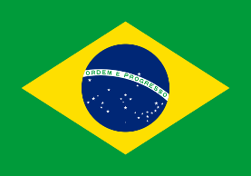
“Everyone should be defenders of the rights of children and adolescents because we are the basis of future generations; respect comes from mutual respect among all.” (girl, 15)
"We believe that we are all equal in our right to health and public education, and must defend those rights for all young people." (boy, 16).
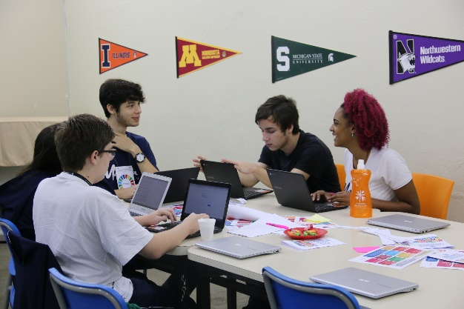
"Young people have access to information from all over the world. It is easier to mobilize for human rights and, consequently, for effective action. We teenagers have advantages we know how to use." (boy, 16).
"Who better than children and adolescents to interact with and motivate children and adolescents? The contact between them provides and generates interest in giving and receiving support." (boy, 17)
"Children represent the future of a nation; they can develop the fundamental role of building awareness, particularly among young people. It is generally easier to talk to people of the same age group." (boy, 17)
“Guys, human rights is what you ask for—if you complain that you have no squares in your neighborhood, that there are no parks, know that this is your right. If you cannot get a place in your school and lose a year, know that it is your right to study." (girl, 13)
"It is our right to be able to give an opinion, and not have everything we say be interrupted in the middle." (boy, 14).
About risks, threats and challenges: "Adults do not believe what children say. They do not trust us. We are ignored." (girl, 9)
"When people hit me or curse me on the street, I have no one to turn to. Nobody helps me when I need it. They do not care." (boy, 12)
"The act of defending such rights is considered a very dangerous task. Human rights defenders are the victims of threats, aggression, and even homicide, whether by authorities or other groups." (boy, 14)
"[Human rights] are not guaranteed when your gender is not respected, or when your appearance or manner becomes a joke. They are not guaranteed when being what you are becomes wrong." (girl, 14)
"The rights of children and adolescents are not guaranteed in their entirety, because there are not sufficient nurseries and schools that have a good infrastructure and provide appropriate education. The lack of hospitals possessing facilities to provide basic care for the young affects mainly children of low social classes." (girl, 15).
"Every human in spite of what circumstance may have led him to commit an act, even a crime, has the right to a defense. And this defense should not cost them their integrity." (girl, 17)
What helps you to act as a human rights defender? "Awareness of the rights of everyone, and the empathy that leads children and adolescents to revolt against attitudes that disrespect human rights." (boy, 17)
"Having a place to socialize, where children and adolescents can talk and have their needs fulfilled." (girl, 15)
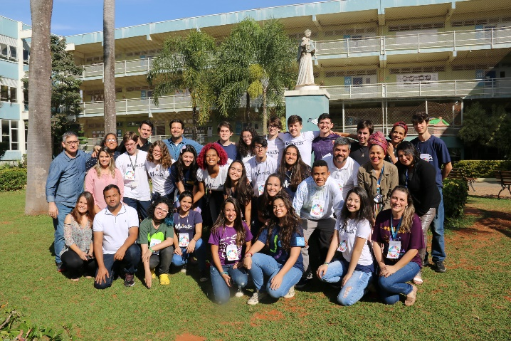
"The ideal world would let children study, play, and do whatever they want, except adult work." (girl, 8)
"It is important to address these issues with children as well, and not just with adults. Because I think we have to say the things we think. We need to talk." (girl, 10)
"Taking care of the poor on the street and giving them food to improve the status of their health." (boy, 10)
"Using the spaces they give us voice to express what we need." (girl, 15)
"Helping parents to have a more open dialogue with their children. Education around abuse of children and adolescents. Including psychologists in public health care." (girl, 10)
"Ensuring the protection of children through contributions to public policies in the area of security. (girl, 15)”
"Organs such as the United Nations can promote laws to better protect children and adolescents, especially in the digital environment, and also implement projects that raise public awareness." (girl, 16).

- AUSTRALIA
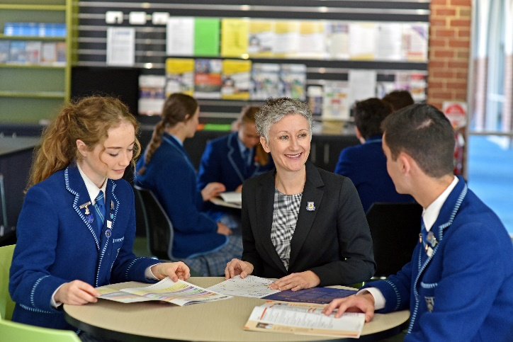
Who should be recognized as children human rights defender? “Children from all economic backgrounds; children from all over Australia - from cities, regional areas, remote areas; children from indigenous communities; children in juvenile detention.” “Children who stand up to bullies are children rights defenders.” “Anyone who is willing to put their hand up and who is directly influenced or has the potential to be affected by Child Human Rights issues.” “As children in a privileged, first world country, we believe that we should take more responsibility for defending the rights of those in countries with a lower socio –economic status. We should be supportive of the children who are the real defenders for their rights in order for some sense of equality to be achieved.”

What is the role that children play as human rights defenders in society? “Can help adults to understand the experience of children in the changing circumstances of today.” “To make things better for the next generation - what we ruin now is what needs repair in the future (or now?)!.” “Children are more open-minded - they don’t have the same fixed mind-set as older generations.” “They have unique and often unbiased views on many issues and will often act in ways that are right and just.” “Children and young adults should play a key role in inspiring others to defend human rights encouraging a strong world view and positive society.” “Standing up for injustices within schools such as bullying and helping out with charities.” “Children can play a large role in the reduction of injustices in their local communities. The innocence of their minds allows them to stand up for what is right as they are not afraid to be different.”
How can children use their capacities and experiences to act as defenders? “Having a direct or near direct experience for a greater ability to empathise and then further defend for the issue.” “Fresh ideas, creative ways of drawing attention to the issues.” “Some ways to raise awareness include mission work, immersions and communication with young people around the world.” “Politicians need to work with young people, making sure they are aware of the platforms which are available for them to have a voice.”
How can children human rights defenders empower other children and receive support from them? “Forming groups of similar minded people who are passionate about the issues.” “Talking around the issue with quality debate and considering the differences in opinion.” “We believe that it is better for young people to educate other young people for real formation to occur. We need to hear their stories firsthand and social media is the platform which would enable this to occur.”
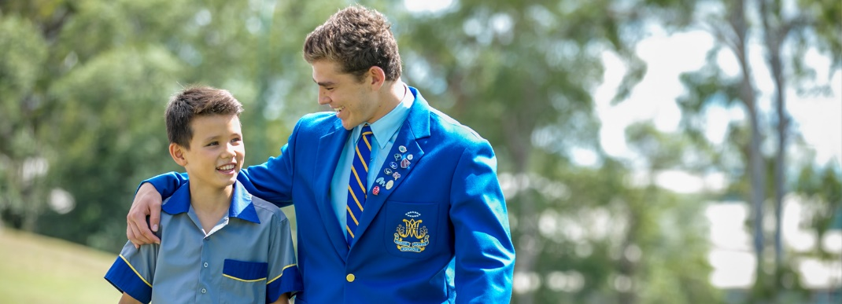
What are the barriers that children face at local, national, and international level? “Adults who do not take children’s voices and experiences seriously, or who ignore them altogether as they see that as the adults their experience is what gives them expertise.” “Culturally there is generally a belief that adults know better. This can be exacerbated by the fact that most children have a limited understanding of how politics, religion, laws work.” “When children are ignored or ‘shut down’.” “When they are judged by others as being too small, too weak, too powerless.”
What helps children to act as human rights defenders? “Opportunities to speak out and act as human rights defenders in their homes, schools and communities.” “Education about human rights and the rights of the child. Helping young people understand or know about the issues in order to speak out about them.” “Teach children that they are powerful. Show them how to use their voice.” “Have significant adults who encourage young people to make change. Schools are the ideal environment to do this.” “Adults need to see children as being capable and powerful human rights defenders. This includes allowing children to exercise this power and assisting them to do so. Rather than ‘reigning it in.” “Without education children will grow up lost and accept injustices, thus they will never speak out and help improve the world. It is important adults help children learn and grow so they can properly influence the world as they deserve to.”

- MADAGASCAR
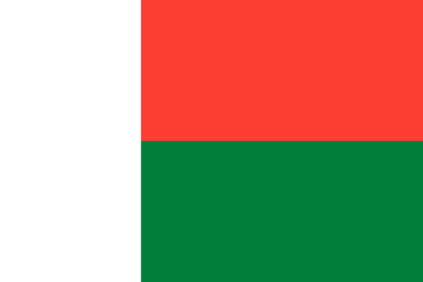
What role do children play as human rights defenders in society? “A children rights defender is a person who helps and guides children to know their own rights, to give them chances to be free when they want to give their opinions.”
“As a human rights defender, my role is to raise awareness in promoting child protection and be a witness to love and to take care of all children, above all those who are neglected and those who are voiceless.”
“To report to the responsible (authority) all cases (abuse and violence) that makes children unhappy. For example, the practice of certain punishments in schools.”
“Our role is to be near the children and to give them the chance to raise their voices so that they will be capable to express themselves and give their opinions.”
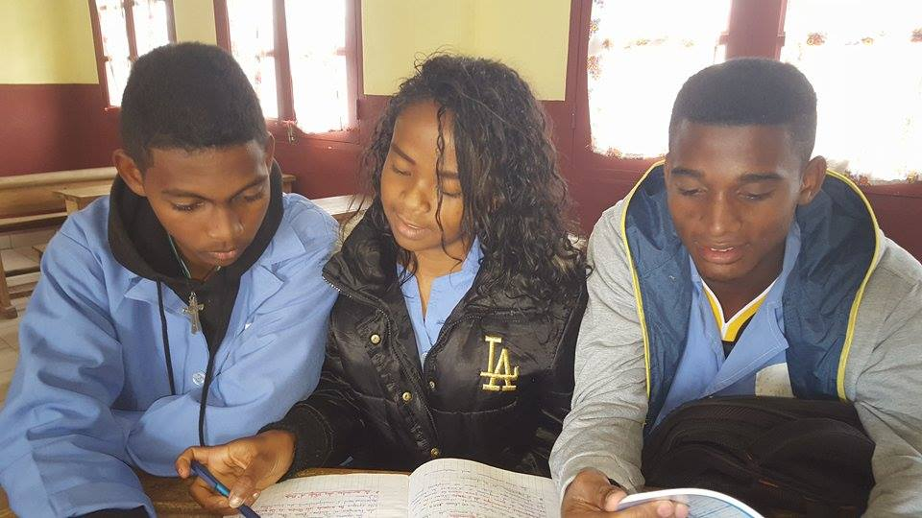
“We discover our own rights and that make us human rights defenders. From that we are called to act as a person responsible to protect our rights and the rights of others.”
What barriers do human rights defenders face at a local, national and international level? “Poverty is one of the challenges that make this issue of human rights very difficult in our country.”
“The cultural background does not allow children to act as human rights defenders. The elders always have the rights and the last words.”
“Children and young people are the majority of the population; this is for us a hope to change people’s mentality and support them to be a good example of a human rights defender.”
“At the national level, laws to protect human rights are not practiced; it is just a written document in some cases.”
“Governments do not have good policies to defend human rights.”
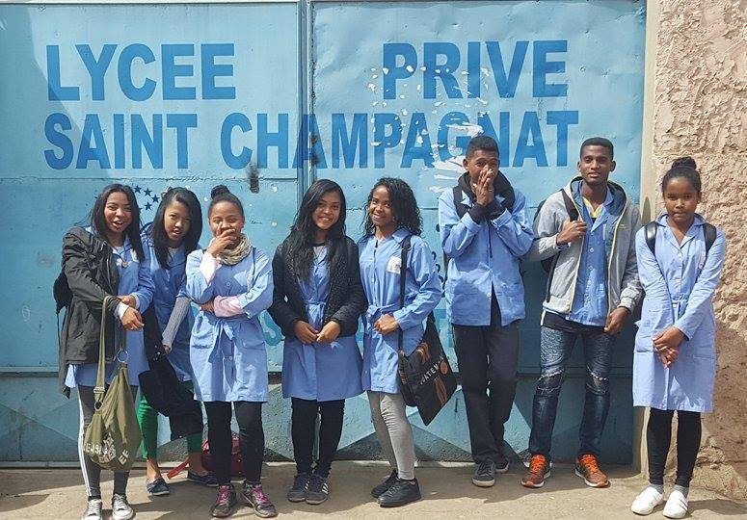
“In some places, culture influences people to not respect human rights. Twins as bad luck babies: people believe that raising twins brings misfortune, even death to their families.”
“Children wish that adults would support them to know more about their rights.”
What helps you to act as a human rights defender? “More information and education about human rights are needed in order to strengthen children to become their own human rights defenders.”
“Children ask adult people to support them to raise their voices so that they can give their own opinions freely.”
The role of social media. “Social media is a fast way to promote people and children to become defenders of their rights.” “This is a very simple way to talk about increasing awareness of human rights.” “Posting images and quotes at school for human rights awareness can influence a lot of people.”

- PORTUGAL

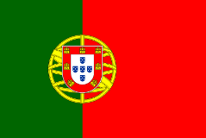
Characteristics that are fundamental in the defender of human rights: “Children who defend human rights must be persistent, courageous and hopeful. They must be people who strive for equality and who have an overview of all kinds of problems.”
Characteristics that are fundamental in defenders of human rights: seriousness, persuasiveness, good communication skills, initiative, willpower, selflessness, setting good example, youthful optimism, extroversion, active, courage, conviction, coherence, determination, humility, charisma, leadership, creativity, good cheer, diligence, honesty, intelligence, generosity.
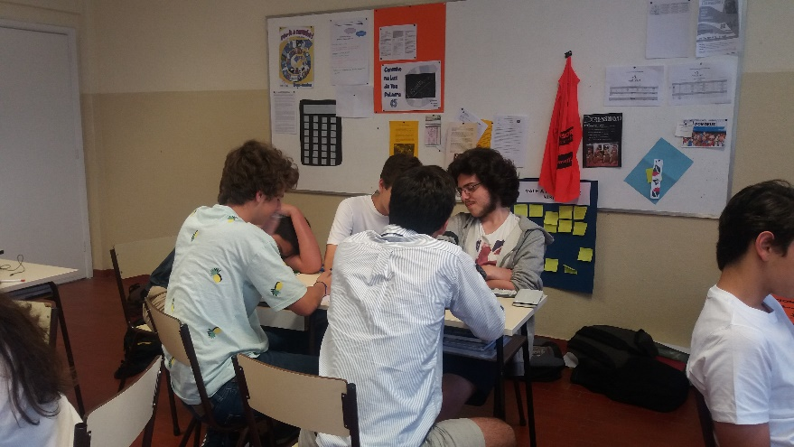
Who should be recognized as children human rights defender? “Defenders of human dignity that take an active leadership posture. Someone who identifies problems and responds actively in solving them. Someone who thinks for himself.”
“My classmates and I consider ourselves human rights defenders because we're all about world peace. We have worked on child labor and slavery. We got involved because we want to make this an international matter!”
What issues do you work on? “Volunteering with the homeless; collection of toys and materials for disadvantaged children. Problems involving youth terrorism, climate change, hunger, homophobia, sexism, racism, the shaping of mentalities, social abandonment, war, domestic violence, excessive use of technology and lack of human contact, bullying, global warming, refugees, discrimination, slave labor, poverty, pollution, social exclusion, ecological sustainability, garbage produced, child labor, lack of love and care in the families.”
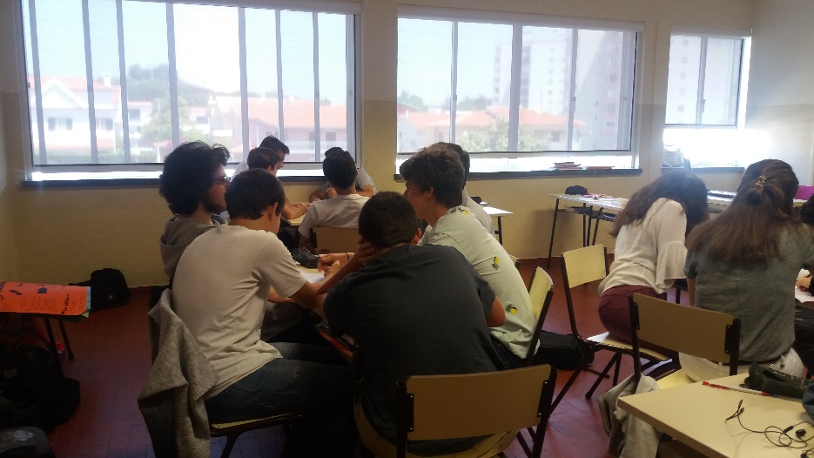
“I often find myself defending the rights and beliefs of others, trying to solve all the problems I face with the greatest respect, patience, and calm, so that everything is resolved only through dialogue and dialogue. While there are many areas in which we recognize that interventions are extremely important and urgent, we focus on child labor, as this is inconceivable and something we despise because of the disparity between our lives and the lives of those living in this situation. We get involved because we want to make it an international issue in such a way that no country is able to ignore it or turn a blind eye to it, even if there are other problems that we would like to expose.”
What are the challenges you face as a human rights defender? “Pressure to conform; the possibility of corruption; fear of others’ reactions and of being penalized for giving my opinion; dealing with different opinions; being misunderstood; apathetic attitudes; discrimination; the fear of being known publicly; difficulty in effecting change; criticism; having courage to fight for what I believe in; lack of social standing; convincing and motivating others; shame from the opinions of others.”
What others have to stop doing to make it possible for children to act as a human rights defender? Schools: Need to stop preventing young people from giving their opinion and conveying what they feel; need to stop devaluing young people and their opinions; they should not pressure young people to adopt ideas but instead give them freedom of thought; should not focus only on the transmission of knowledge and notes / Families: should not reinforce stereotypical roles; should not see young people as immature; should not create prejudices; should not impose ideas; should be less conservative; should not refuse to listen to children; should not dissuade children from doing what they want; should neither overprotect nor spoil children.
What role do adults play in this? “The adults can help us a lot because they know a lot, however they do not understand us.” (girl, 11) “The adults have more experience but sometimes they do not listen to us properly.” (girl, 14) “Adults must have a key role in this context, since they can give children some voice and help them in all they need, while letting them know whether they are doing right or wrong. Even though they (adults) can give children guidance and encourage them to speak, generally speaking, those in position of great power do not listen to children.”

- PARAGUAY
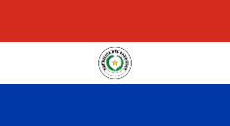
Regarding definition: “[CHRDs] are children who work for their OWN RIGHTS OR the RIGHTS OF OTHERS. CHRDs work on MANY ISSUES like bullying at school, protecting the environment or stopping child marriages.”
Regarding the characteristics that people must possess to defend their rights, they mentioned empathy (which seeks the common good); willingness to fight for their rights without fear; openness to expressing their opinion. Something fundamental is that we know our rights and defend ourselves.
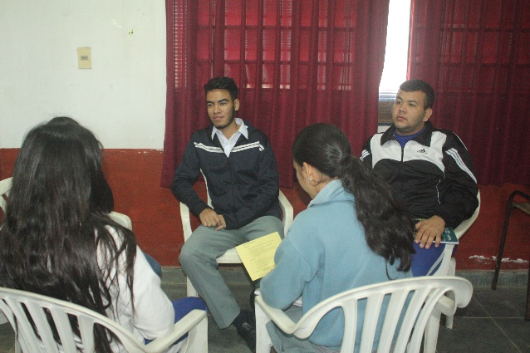
Regarding specific people who defend human rights: they mentioned the Marist Brothers and the Marist SED Foundation (Solidarity, Education, and Developmet); we are all defenders of our rights, but we are not called "defenders.” They agree that "Defenders of Human Rights" can be anyone, anywhere (starting even at home), regardless of age; but yes, you need to first KNOW YOUR RIGHTS.
According to their own expressions, the participants pointed out that the issue of Human Rights was unknown to them. They mentioned that awareness and knowledge of Human Rights is very important, but that it is not enough; each country should guarantee that these rights are respected so that it does not remain only theoretical.

They advise the Committee on the Rights of the Child to address the following:
1. Eradicate domestic violence.
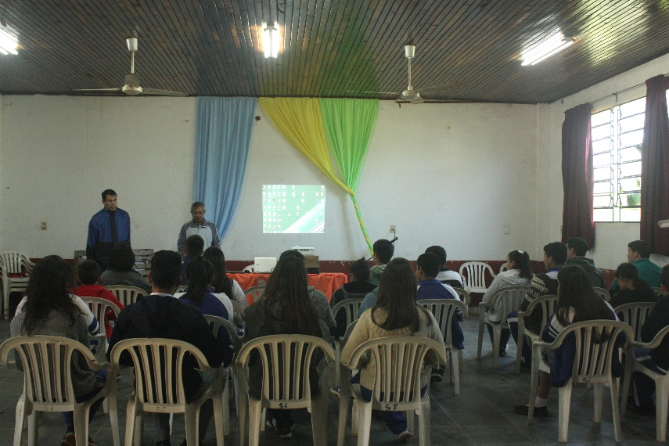
2. The State should guarantee greater investment in Education.
3. Combat the use of the Internet for purposes that harm and do not respect the Rights of the Child.
4. Ensure gender equality.
5. Ensure inclusive education and eliminate discrimination.
Those who answered these questions were 25 children, delegates of courses and some of the Course Council from the Marist School in Limpio. This is a community located in the Central Department of Paraguay. It is a community of children whose rights have been violated. These children and adolescents have been raised by third parties because most of their parents emigrated to Spain or Argentina for work.

- PHILLIPINES
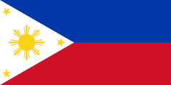
“What allows us children to act as human rights defenders is our responsibility. We all have the responsibility to uphold our rights and to respect the rights of others.” “I want to change the perception of people that we are only children. I want them to know that we are children capable of expressing our opinion and fighting for our rights.” “We are not only playful, but also the hope of the next generation to come. We are more than just toys, games, and gadgets. We are what the future holds.”
What role do children play as human rights defenders in society? “A child’s role is to help nurture and preserve children’s rights.” “My role as a human rights defender is to give positive witness and to be a co-contributor in society.” “They serve as the light for the community. They help others to be enlightened.”
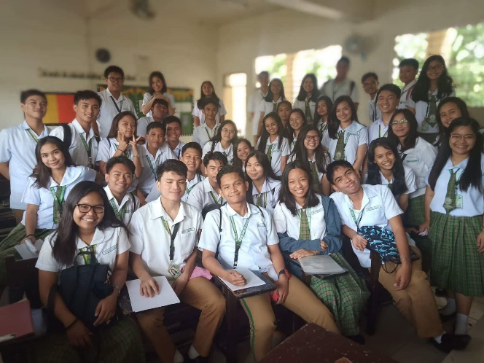
What allows children to act as human rights defenders? “Our own rights allow us children to act as human rights defenders.” “Our National Hero Jose Rizal once said: “The youth are the hope of the Nation,” and since we are the hope of our nation, this allows us to act as human rights defenders.” “We all have the responsibility to uphold our rights and to respect the rights of others.” “It is my own conscience. It allows me to know my own position and to know what I am capable of doing. Doing what is necessary with an open mind and heart that is just.”
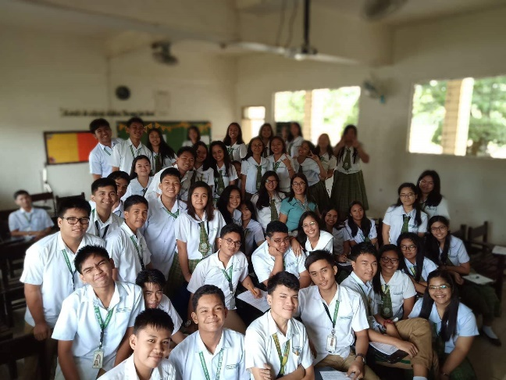
How do children of different ages, genders and situations in life use their abilities to be a defender? “Children can use their abilities to be defenders by maximizing their talents that were given to us.” “Each child has different/unique stories and experiences. That’s the edge of other children. They can show to other people different sides of the world.” “Children of different ages, genders, or social statuses can be defenders for human rights in their own ways. There are groups who use technology or social media to spread their advocacy.” “Student leaders attend seminars and implement projects in their school.” “Indigenous children protect themselves against discrimination using social media as their platform.”
How can child rights defenders empower other children and receive their support? “I can empower children by telling them how important defending our human rights is. They can empower others also by campaigning locally about human rights and how to protect them. The best example is MALALA YOUSAFZAI.” “I can empower and support children by teaching them to be strong and by showing them a different perspective when it comes to child abuse so that they can be aware of it.”
What barriers do human rights defenders face? “Some families, through the influence of culture use physical punishment to discipline a child, for example. Physical punishment is already a violation of human rights.” “In the national level, it’s our government officials that abuse human rights. These include people who are corrupt and those in politics that stop human rights defender from seeking the truth.”
What risks are faced by children who defend human rights? “Being bullied (e.g. cyberbullying) and hated by many, being scolded, and we could possibly be killed as retaliation.” “They can easily be bullied or dishonoured because they are just kids. They might face multiple risks including death threats to their loved ones.”
How do children want to empower themselves and what support do they want? “What children want to empower themselves is the support of adults, especially their parents and the authorities, specifically the social or moral support from adults and the support of education from the authorities.” “What we children need to empower ourselves is knowledge of our rights and an encouraging support from the authorities so we can receive motivation, gain confidence, and defend our rights.” “Children just want people to listen to them.”

- COLOMBIA

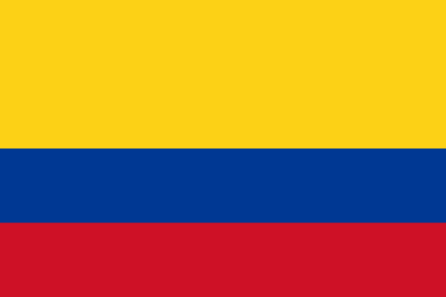
“Knowing your rights is not enough, because we must go beyond simple knowledge. Actions that promote rights must be carried out, especially with the children of the community. Young people must commit themselves to participate in projects that allow the exercise and promotion of rights, for students this could include participation in youth groups such as REMAR.”
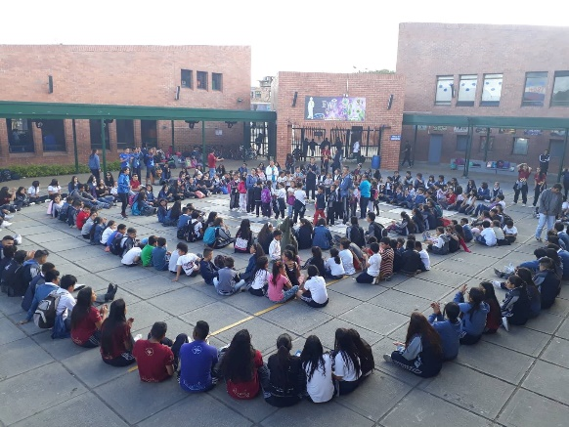
One of the rights that is violated according to students is the right to a free personality, because within the institution it is suggested not to wear makeup, piercings and the use of garments that are not part of the uniform. Students feel that these norms violate their rights. In order to avoid these actions by institutions, participation in mechanisms such as student council, student representatives, student inspectors and other structures legally established in the coexistence manual and in the Colombian legislature must be used.

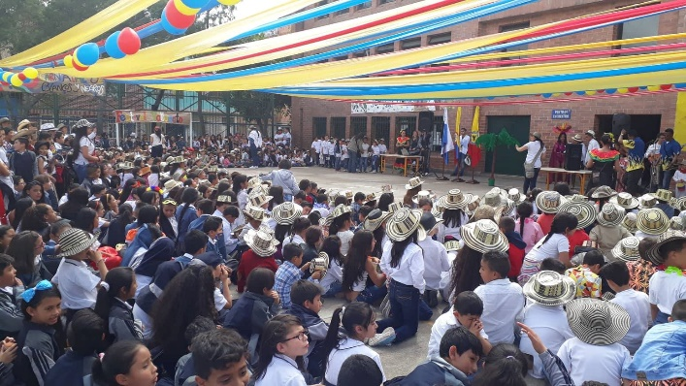
The students first asked for an explanation of what their rights are and what rights they have. Also, why is it important to reflect on these rights? Those who do not know their rights are unable to assert them and will never fight for them.
Los Naranjos School in the town of Bosa serves a population of 1,548 students. The vast majority of students are lower to lower-middle income. Some of the main problems: 24% of its inhabitants live in poverty, and 5.2% in extreme poverty. High rates of violence, narcotics consumption, and other problems exist as well.

- SPAIN

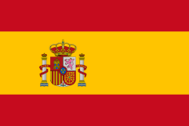
Do you see yourself as a defender of human rights? Practically all indicate that they do see themselves as defenders of human rights, because they like to "help themselves and others" even though they admit not being "active.”
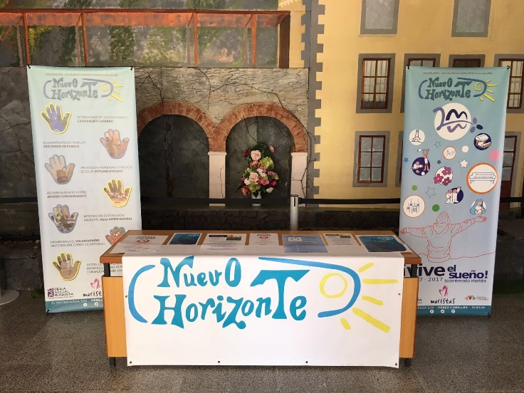
Do others see you as a defender of human rights? Here the almost unanimous answer is that they do see each other but they believe that others do not, only those who truly know them.
What issues do you work on? Here participants highlighted the "fight against harassment", although there are other very varied responses: "respecting the beliefs of all", "respect for others", "being heard", "protecting the environment", and "charitable giving.”
Why did you get involved? Almost the totality indicated the belief that "[these] are important issues" and "help is needed", specifying in some cases that "nobody is less than anyone.”
What are the challenges you face as a defender of human rights? "fighting against harassment", "protecting the environment", "not being taken seriously", "criticism", "having a family that does not listen.”
What helps you to act as a defender of human rights? Some indicate first their peers, and second, their family and teachers. Others just say, "it makes me happy", "knowing that I help others", "and the collaboration with others.”
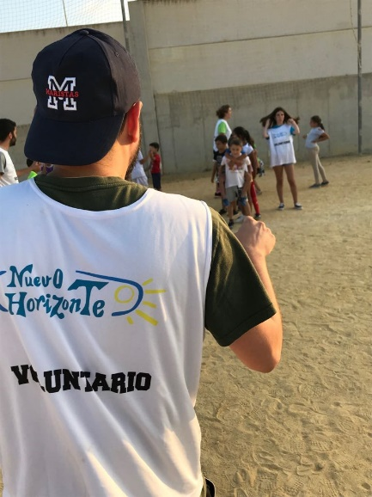
What role do adults play in this (positive and negative)? Positive: Sharing their experience, fighting for government action, being valued decision-makers, those who teach positively, and those who remember that they were once boys or girls. Negative: They don’t know how children feel, they don’t take them seriously, they can be greedy, and they do not care enough for children.
What can others do to make it possible for children to act as defenders of human rights? The general opinion is that the human rights should have more visibility in schools and schools should give more information so that everyone knows their rights and can defend them, pointing out that governments should devote more resources to it. Schools and families should dedicate more attention to this matter. Children must assert themselves and hear more.

Do you use news, television or radio in your work as a defender of human rights? The vast majority answered that they sometimes watch TV and listen to the news on the radio to learn about topics that affect everyone and that they use information mainly to work in subjects such as religion.
What kind of things do you do to promote your work in social networks? Those who use networks share images, make chains of support to someone or something, sharing phrases or texts ...
How could social media platforms be improved to help you in your work as a human rights defender? "by giving publicity to human rights with phrases that everyone sees" or "increasing motivation around the subject"

- ARGENTINA
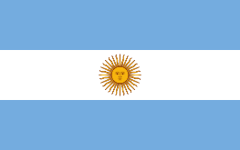
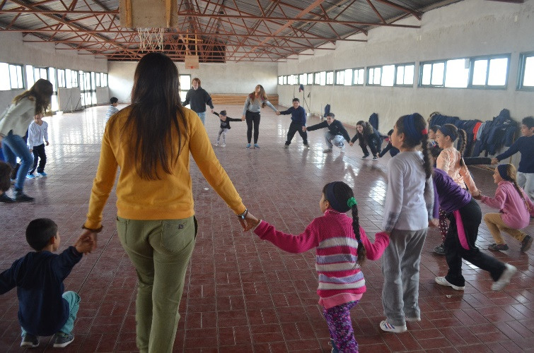
Characteristics that are fundamental in defenders of human rights: “A human rights defender is: empathetic, goodwilled, generous, trustworthy, affectionate, supportive, friendly, fair, informed, willing to help, understanding, intelligent, hardworking, open-minded, an ordinary person, considerate, articulate, knows what he wants, does not make differences, does not remain silent, is respected, and knows the rights.”
"His voice has to represent the voices of the minorities", "He has to know how to put himself in the place of the other.” "The defender has to be brave, fair, and persevering.” "The defender has to be responsible and committed.”
Who should be recognized as children human rights defenders? “We believe that today the image of an adolescent as a defender would be more representative, as well as the rights of girls and women." (girl)
"We have to know them (the rights) in order to defend them." (girl, 12)
"A small child has the same rights as an adult, and a child can know about the subject and be more responsible." (group of girls)
What issues do you work on?
"It is important to neither discriminate nor be discriminated against.”
"Right to identity, it is to have a name, nationality, and know who your parents are. This was not fulfilled when the military was there. There are still adults who do not know their truth.”
"The right to play is only fulfilled in kindergarten, when we grow up not it is seen as a right.”
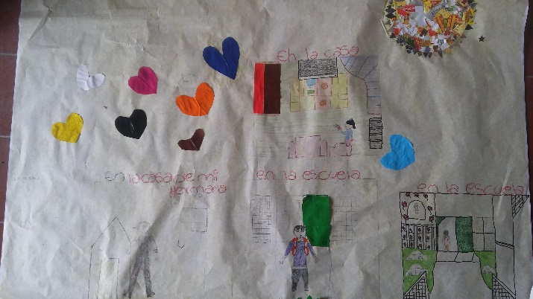
"We think that sexual diversity is important, that everyone can decide without discrimination for feeling different from the rest of their friends.”
What role do adults play in this (positive and negative)? "On the positive when they listen attentively and give value to what we express.” "Some teachers play a positive role when we raise questions and listen to us and help us find the best option to solve them.”
"Sometimes it is negative because they decide for us.” "Adults believe that our opinion is worth less than theirs because we are children.” "Adults play a negative role when they want to have the last word without thinking they are wrong.”

"Give us the place and space in school to exercise our rights.”
"Respect our feelings and what we choose to be in life"
“That in the discussions on issues that refer to adolescents, they give us the place to speak, that they respect our opinions and take them into account at the time of decision.”
"That they teach us how to we can defend our rights.” “We believe that to be defenders we have to know the laws and rights, but we cannot do it alone.”
"Society is consumerist and there are many stereotypes, we believe that a girl would be a better defender of rights, but companies sometimes build ideals about women who are then frowned upon when they get involved in politics.”
“We can all speak and we have the right to be heard. We believe that if you listen to an adult you should also listen to and respect a child, pre-adolescent and / or adolescent.”
“It would not have much impact on society because we have the idea that adolescents do not have the right to express their opinion on this because they think we are not informed.”
“It can transmit the same as an adult, but in a different way and not with the same knowledge. They are not respected or heard as adults and thanks to this, their opinion would not be taken into account.”
Their advices to the Committee were to deal with the following:
- Eradicate gender violence, child maltreatment, slavery, bullying, discrimination and violation of rights;
- The State should guarantee an integrated sexual education and promote alcohol and drug education.
- Ensure care for the environment, non-use of agrochemicals and improved treatment of animals.
- Ensure the right to expression, the right to food, access to the internet and opportunities for children and adolescents to participate in society.

- CANADA
“Terrible things are happening in the world that can put us in unbearable situations. In order to defend our rights, we can use social networks to share our opinions and disseminate issues that are important to us in order to try to change things as quickly and sustainably as possible. We can also participate and / or organize marches to join people who want to debate and be heard for a cause.”
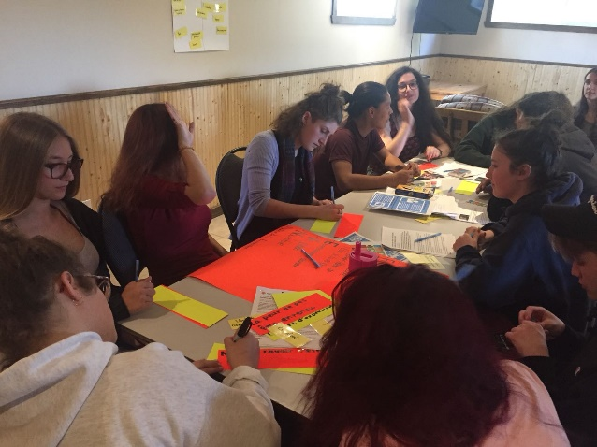
“We believe that in Canada many issues can be discussed openly. Everyone can have their opinion and share it without fear. Several organizations organize marches, activities and workshops to invite young people to mobilize for a cause.”
“Piercings and tattoos are a new form of expression. It is about our body image. By prohibiting them, some schools prevent us from expressing ourselves freely.”
“Indigenous communities receive very little government support. The services and activities offered to young people are very limited.”

“We see the government offering better living conditions to the refugees it welcomes than to the native communities. Many young people are left alone and do not have access to a safe living space.”
“We need spaces where we can be heard and where we can contribute to decision making. All too often, on the pretext of being too young, they do not take our opinion into account.”
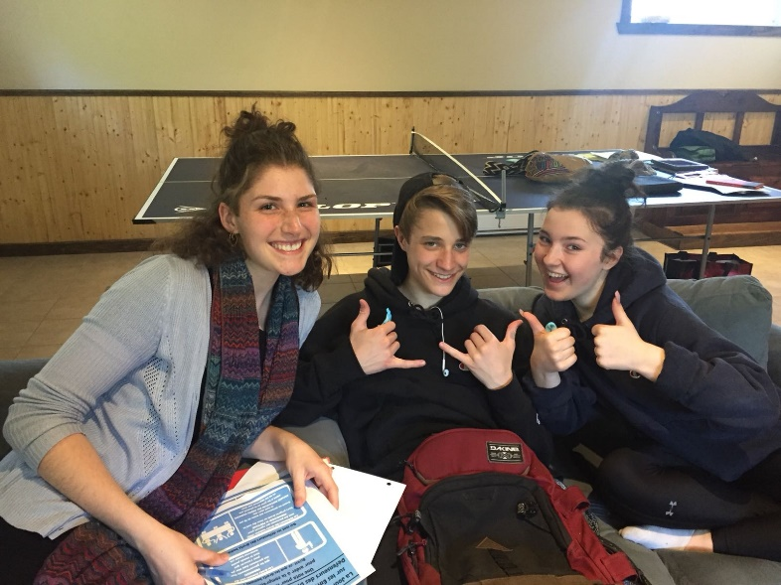
“Many families need the services of the food banks. Too often, these food banks do not have the capacity to provide complete and balanced meals for families that require these services. Measures must be taken to support food banks.”
“Being young, adults do not really take our opinions into account. Sometimes, they say they are interested: they listen, but they do not act.” "Nobody told us about our rights before (from the workshop).”
“Unfortunately, sometimes, it is difficult to fight for our rights at our age because adults do not necessarily take us seriously. Adults often deny our opinions because of our age. However, we want the same rights as the rest of the population. We want to be able to judge what is wrong in our world and act to change it.”
“We do not define ourselves as defenders of human rights. It is a paper that seems very large and complex. Now that we know our rights, we will be more aware of respect for our rights, but also of respect for the rights of young people around us.”
“We believe that the defense of human rights is a role for international organizations... young people cannot do much because they are young. Our impact is minimal.”
“Young people need more individual attention. Nobody likes to feel like a number. It is important for us to have a meaningful link with responsible adults (social workers, teachers, educators, etc.). We appreciate that our teachers know our needs, strengths, abilities and limitations. We need to understand the reasons for the decisions that concern us.”
“We need to stay with our family, even if it has weaknesses. A balance in the relationship is needed, especially during adolescence. We need love, but also space to breathe and grow. We need spaces to participate in the decision-making that concerns us.”
“Social networks are very interesting spaces to spread messages and raise awareness. They are platforms that young people consult a lot.”
“Social networks are the means that we as young people consult the most. It is our main source of information. We believe that to do the job of promoting human rights, we should spread our messages on the networks.”
“Today we reach the public via social networks. Adults are allowed to make publications about us without asking for our consent. Dramatic personal experiences quickly turn into public dramas that can be debated in the public sphere.”

- CHILE

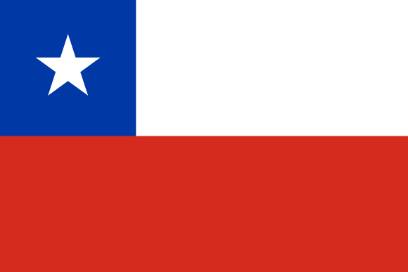
The main characteristics of children defending human rights are empathy, awareness of the needs of others, solidarity,y and having the ability to worry about what happens. Therefore they must be informed and have critical opinions about what happens in all situations. They are courageous and respectful, and they are also creative and innovative to propose new initiatives.
"The defender must promote and help fulfill the rights." (boy, 15)
"They fight for the equality of rights in all human beings" (girl, 12)
“We consider ourselves as human rights defenders, although there are many people who do not know what we do and believe that we waste time. They question us, but also many others know what we do—they recognize us. It is our job to visualize what we do, get people to break their bubble, and know what it is about. We are human rights defenders, because we care about the problems of others. We are informed and we want to promote change.”
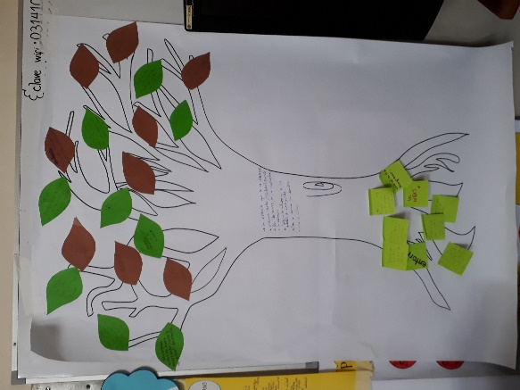
“The main problem we are working on is related to the violence we always see, and its normalization. We want children not to get used to violence; we have to make their rights known to generate a change in culture" (boy, 17).
What should governments / schools, etc., stop doing?: "Adults need to put themselves in the place of children so they see from that point of view what is lacking" (boy, 16). Families: "Stop being so critical, do not focus only on errors, punishing the act without promoting improvement"(boy, 14). Schools: "Stop comparing and putting pressure on students." (girl, 15). "Schools need more awareness of the student's personal life" (boy, 14) ). "Stop valuing the students quantitatively" (girl, 17). "Stop enforcing unnecessary regulations (long hair, painted nails, etc.)" (girl, 15). Government: “Stop looking at us as a number, we are not a consumer good.” “Governments should not discriminate; they should ensure justice for all, and also be concerned with excessive inequality.” "Stop providing bad services related to education, health, and well-being" (girl, 12).
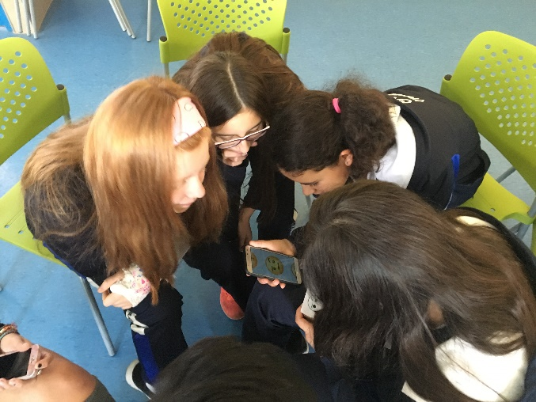
“It helps us to have the support of our classmates, to create with us and listen to us, for our classmates to give us understanding, respect and the confidence to carry out the projects. That they do not leave us alone: ​​that they take part, organize, and inform" (girl, 14).
“What is needed from adults, mainly, is that they listen to us, take us into account, and take us seriously—that they know they can count on young people. Respect them and support them in the ideas and projects they have undertaken: "That they take us into account as peers and when deciding things that involve us all" (girl, 16).
That schools "continue promoting inclusion" (boy, 14), "Continue considering us in institutional decisions, like the student center does." (boy, 17) "Give opportunities to promote the knowledge and importance of human rights " (girl, 14).
"Social networks serve to generate awareness among our peers through sharing our experiences..." (girl, 17). "They allow participation under equal conditions." (boy, 12) "We communicate with other people from faraway places."(girl, 14) “Social networks allow us to communicate directly, for example with WhatsApp; we use it to organize projects and to connect with others who are in similar situations.” "If we agree, we can publish some images all at the same time, which generates a shower of information..." (boy, 17).
Their advices to the Committee were to address:
- Quality education for all without discrimination, especially regarding the most vulnerable.
- The protection of all children against violence by adults (sexual abuse, abuse of power, abuse in general).
- Ensure that care is provided in foster care and that laws are in place to ensure the adoption of these boys and girls.
- Ensure that vulnerable children can access quality education and that they reach the end of their schooling.

- MEXICO

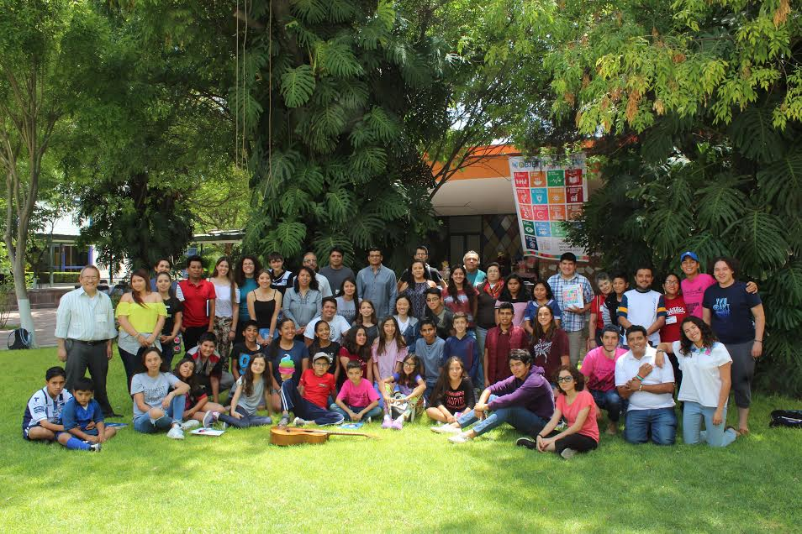
"I imagine defenders of human rights to be active in the great causes at the United Nations. But when we think that human rights are also defended through small actions, you realize that you are one also.”
Do you see yourself as a human rights defender? “I take care of my rights.” “I care for others and I bring something.” “I always defend the children who feel bothered.” “I fight against harassment.” ”We promote human rights.” “I am firm in my decisions and view others with dignity.” “I know the rights and spread knowledge of them.” “I Share and teach what rights are.” “I was a volunteer in the earthquake, in the House of the Migrant… In the Youth Ministry and in other movements outside of school, forums, councils, in addition to campaigns and activities with young people.” "Volunteers, a neighbor offered to go to teach a household, thereby promoting the right to education.” "The right to recreation is an important right, we provide materials so that children can live this right.”
What allows children to act as human rights defenders? “Do not take rights as a joke, they are serious.” “Do not ignore rights. Share information with others.” “The support of the family and the school.” “The values ​​that my parents instilled in me.” “Values ​​taught to me by my parents and my Marist school.” “The golden rule: Treat others as you would treat yourself, there is no justice in the world.” “Realizing how rights are violated.” “Seeing the injustices and so many people who are wronged, but still help. That inspires me.” “Realizing my rights and if they are violated or others want to violate them....” “Knowing them, informing other children and not letting them be like statues. You have to plant the seed.” “Know that, if I help them, they will be better people later.”
“That there are spaces to share and participate.” “Disseminate rights, demand them.” “Make meetings and hold talks so that children know their rights and share them.” “Be more fair with everyone.” “Motivate and explain how it is and what they can support.” “Support, giving reasons so that others can accompany them.” “We are look for the dignity and value of the person”
What role do adults play in this (positive and negative)? “They are the ones who work and vote. They decide our future. They are our example.” “Sharing information with us.” “They are the first defenders.” “It is important for them to educate children, they take care of us.” “They are the ones who many times help to open doors.” “Sometimes they are the ones who violate rights.” “There are closed-minded adults who do not help. Not everyone is responsible for what happens.”
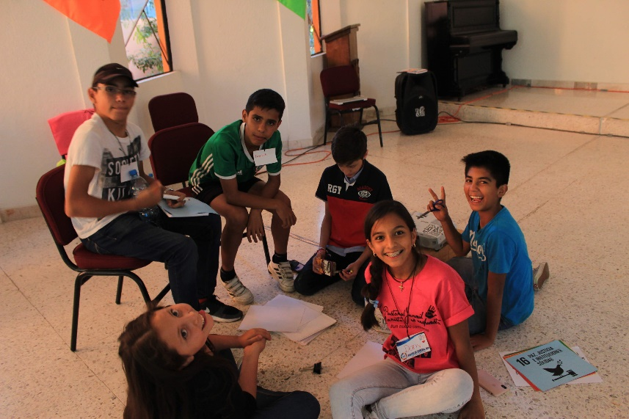
The role of business: “There are companies that pay to respect water.” “They tell us one thing and do another.” “Companies can use incentives.” “Industries have permits for part of the state, they pay and they are regulated by the state.” “Corrupt practices impact these situations.” "Respectful treatment and fair work.” “The water should be free and available from the tap.” “I have not seen, but I have heard: Some companies do not give workers their rights and make fun of them.”
The role of social media: “In my school they have been used several times. The advantage is that several people can find out what we do.” “When I have given information and I know it through the media.” “Its advantage is that they keep you informed.” “I have shared a lot of UN media.” “You reach more people. With electronic complaints, blocking people.” “In my school we made a network for infographics and human rights campaigns in Acapulco.” “I committed myself to share this information in the networks in which I participate.” “Share pages to promote awareness of rights.” “I share information and what I feel and learn.” “The social network should not allow words that discriminate and should report bad posts.” "We upload images to social networks to let people know of human rights violations.”

- USA

USA / MARIST YOUNG ADULT NATIONAL ADVISORY COMMITTEE:
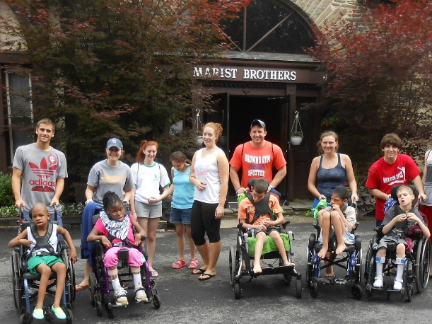
What role do children play as human rights defenders in society? Children play a huge role as human rights defenders in society because historically, when children are involved, more people tend to respond and reflect on certain issues. Everyone should fight for their own rights, especially children. Children are the easiest to be underestimated and looked down upon, but in reality can have a great impact on society.
The role of children is to help adults defend human rights as an innocent party. Children are usually more pure of mind and heart than adults and can see issues from a perspective that older people may not be able to.
What allows children to act as human rights defenders?
Once children have the approval of their peers and people that they look up to, they can act upon their beliefs. It may be hard for some to stand up for what they believe in because they may be worried of being judged, punished, etc. However, if they get the approval of others and reassurance that they are not doing anything wrong, they can act accordingly as human rights defenders.
Easy access to social media, social media platforms like YouTube and Facebook help children be able to voice their needs and wants. Social media and supportive parents allow children to act as defenders. When children are empowered, their voices can have a strong effect.
An education regarding human rights and human rights issues is the first item to allow children to act as human rights defenders. The second item is an environment that is friendly toward the opinions of children.
What barriers do human rights defenders face at a local, national and international level?
Barriers they face can come from governments who don’t support them and also since children can’t be on government at those levels it’s harder for them to be taken seriously.
The barriers that these defenders face are opposing sides such as the ones who seek to infringe on these rights. Other barriers are laws, practices and cultures.
At the local level, they face ridicule from classmates for standing up for something they believe in, particularly if it is a minority opinion. At the national and international level, they face a challenge of being heard and validated.
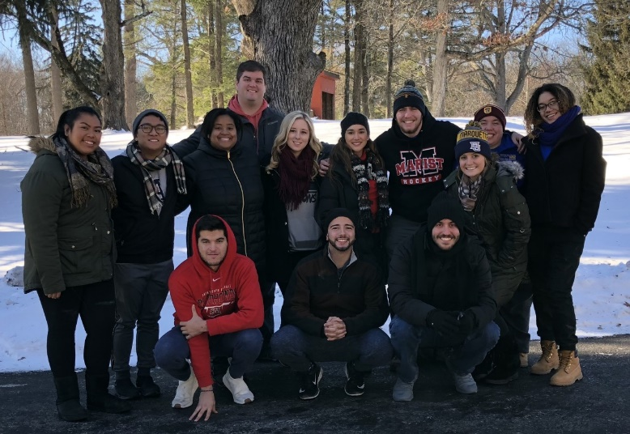
How do children want to empower themselves and what support do they want from adults and authorities?
Children need to come together to address the different issues that our nation is facing. Once they come together, a system can be formed and can empower one another. Although one voice can be heard, multiple voices can speak volumes. Further, adults and authorities should support the children and guide them in the right direction to unite for a given cause.
Students need support from adults on the legal level to enforce the rights of the children. If children are not supported by adults and their government, it is harder to establish new laws.
Children want to have their voice recognized and listened, as protected under article 12. They want their parents and other adults to support them by giving opportunities to have their opinions heard

- FROM THIS PARTICIPATORY PROCESS AND REFLECTION, WE RECOMMEND

- Promote the formalization of mechanisms to investigate complaints and procedures for compulsory notification in cases of threat or violation of rights;
- Ensure the participation of children and adolescents in conflict resolution, creating spaces for reconciliation and dialogue;
- Encourage public authorities to draft laws and programs that guarantee in the basic curriculum, from kindergarten to high school, the subject of children's and adolescent's rights, included with the study of the country's laws and international treaties.;
- Continue improving methodologies of participation and listening to contributions to encourage the exercise of citizenship by children and adolescents as members of committees and deliberative entities.
- To direct the Member Countries to establish in their decision-making mechanisms structures to promote processes to better allow children and adolescents to participate in topicsthat concern them;
- Create a virtual participation tool for children and adolescents to learn about the mechanisms of the UN and amplify their voices together in order to be heard by decision-makers at the highest levels.

