WHEREVER YOU GO

The Marist Brothers’ Rule of Life

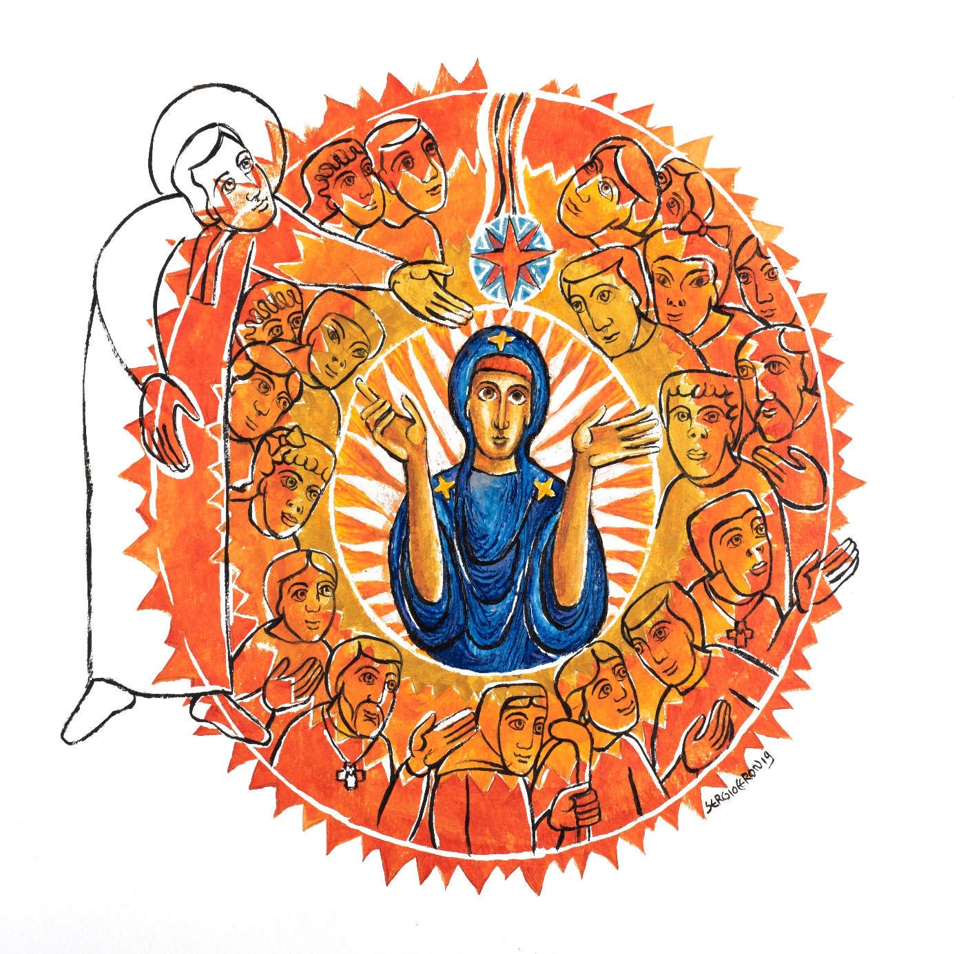
XXII GENERAL CHAPTER
GENERAL COUNCIL

References within the text are limited exclusively to the Word of God and to the basic Marist texts of our origins: Life of M. Champagnat (Furet); Avis, Leçons et Sentences (Furet) and Letters of the Founder.
As in the Bible, the quotation will be generic, valid for any type of edition, although less precise because it does not have verses.
The definitive edition will have notes outside the text, where the source will be specified and there will be other external references.
The illustrations are from Sérgio Ceron.

Invitation

There is great value in being a BROTHER today.
Brother, throughout these pages you are invited to take part in a conversation with your community, the one that speaks to you through this text. The phrase, your community, refers to the brothers in your local and Province communities and, ultimately, in all the communities that make up the Institute.
“Wherever you go, I will go, and wherever you live, I will live.
Your people will be my people, and your God my God too” (Ru 1:16)
These three words of Ruth—Wherever you go—found in the title of this text, convey an almost unimaginable strength, an ability to endure, persist, overcome. They can help you and me to express some of our deepest longings. No longer Ruth’s words alone, they become our words also.
Likewise, they capture Marcellin’s experience as well as that of our first brothers, and, indeed, of all Marists who have preceded us.
- In January 1817, when the founder walked into the house at LaValla for the first time with two uneducated young men, he set out on an uncertain path.
- Likewise, at the beginning of the 20th century, when our brothers in France were confronted with a new law on the Separation of the Churches and State, they faced a similar challenge.
- On the more than 200 years journey of our Institute, we have met some marvellous companions, people who have lived lives that can only be described as extraordinary. Many gave their lives in daily commitment without fanfare; they are already part of “the Church of the apron.”
- Our history as an Institute has been full of new beginnings. And often enough, someone else determined the road that we would travel and the destination at which we would arrive.
Throughout these pages, then, you will find a collective wisdom that has developed over the past two centuries. The Marist experience of so many brothers who have preceded us is a common heritage motivating all Marists to move toward the future.
By reading, meditating on, and praying about this text, you can develop an intimate relationship with its meaning, one that nourishes your daily life and enriches our common heritage. In this personal and intimate dialogue your life as a “brother of Mary” will be shaped.

First Chapter

OUR VOCATION: BEING BROTHER

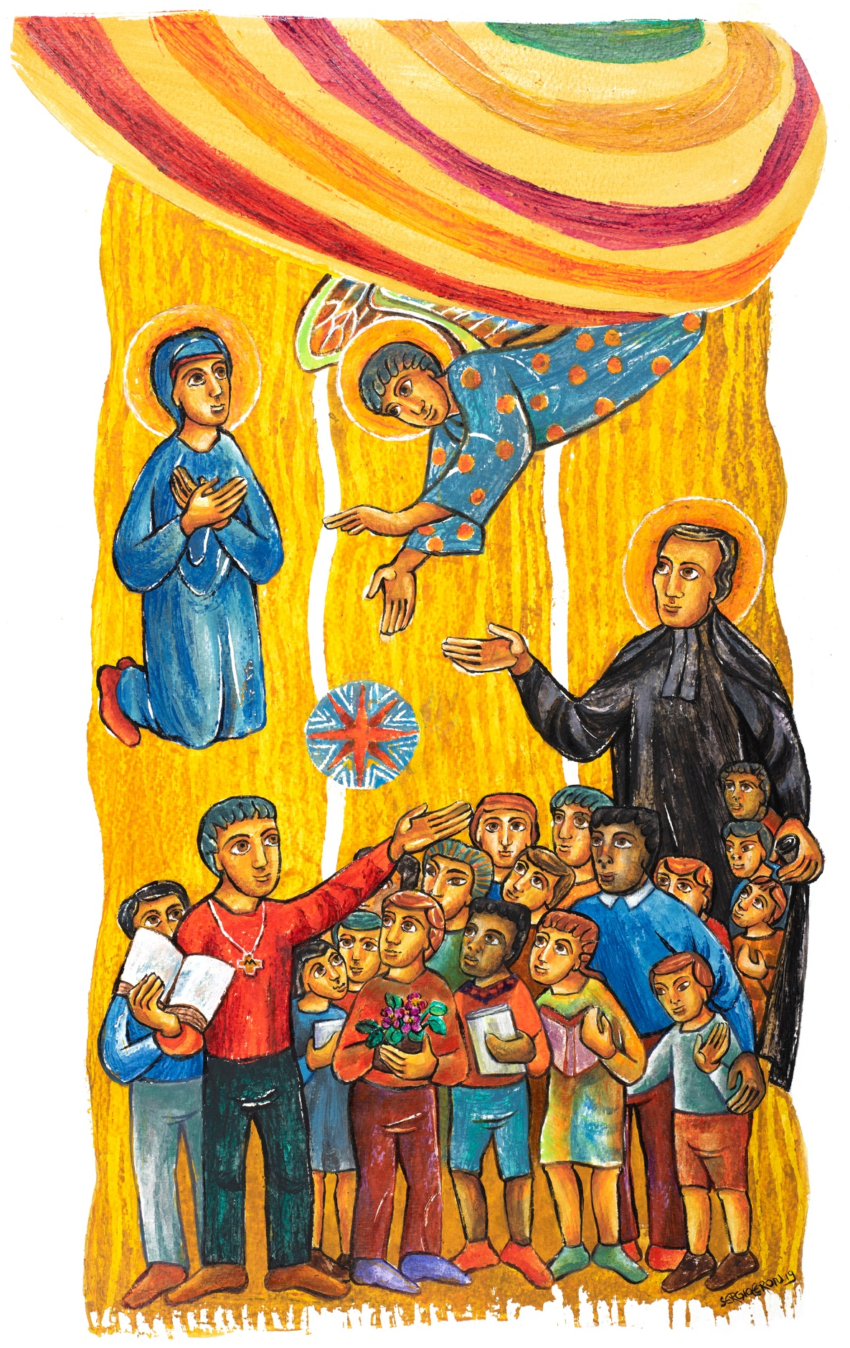

First Chapter - Section I

Brotherhood as a MYSTERY

(A) Contemplating Jesús

“Master, where do you live? Come and you will see” (Jn 1:39)

[1] BROTHER,
take heed as you set out on your journey
and listen to Jesus who invites us to “Come and see” (Jn 1:39).

Your call to brotherhood
contains an element of mystery;
accept it as a gift.
Take on the attitude of a pilgrim each day
and discover that the path that you trod
transforms your way of looking at life
as well as your understanding of it.

Come now, live with the Lord,
allow yourself to be guided by the Master.
Like his earliest followers,
never forget the moment
when Jesus first touched your heart
and called forth your deepest and most authentic self.

His first disciples remembered well
the Lord’s call to “Come and see.”
In response, “they went and saw where he was staying,
and they stayed with him that day.
It was about four in the afternoon” (Jn 1:39).

(B) Brotherhood, the gift that we receive

In this gift, the origin of your vocation is revealed

[2] Your vocation has its origin
in the experience of meeting and being with Jesus.
He loved you first (cf. 1Jn 4:19),
calling you to life and to a life of faith.

The sacraments of baptism and confirmation
welcome you into a new life in him,
and invite you to walk by his side
and to announce the Reign of God.

In your vocation as a brother,
you are called to live out this gift fully and without reservation.
Just as each religious family bears witness to an attribute of Jesus,
you and your brothers are asked
to make visible in the Church and world
Christ’s fraternal face.

In your response, the essence of your vocation is expressed

[3] The risen Lord has called you to live in community.
Your brotherhood is a response to the gift that you have received:
you are a son beloved by the Father,
a brother of Jesus, united with him,
“first-born among many brothers” (Rm 8:29).

Being a child of God and a brother of Jesus
is the primary and essential identity of each person (cf. Mt 5:45; 25:40-45).
Living that identity fully, by simply being a brother,
is the essence of your Christian vocation.

The anointing that you received
at the time of your Christian initiation
invites you to live out the mystery of your vocation
as a partnership fundamental to your identity as a brother, ^{(R.4)}
as a prophetic revelation about each person’s value, ^{(R.5)}
and as a sacrament of the presence of God,
the true leaven of universal fraternity. ^{(R.6)}

(C) Your WORD Lord… “a lamp to my feet and a light to my path” (Ps 119:105)

Brotherhood, a partnership for the Reign of God

[4] The grace of the sacraments
frees you from all that can enslave you
and allows you to be that wonderful and unique person
whom God created and has loved since the beginning of time (cf. Jer 1:4).

As you grow in freedom,
you come to take responsibility for your life,
and develop the capacity to make a commitment.
Your life does not unfold according to some predetermined plan,
needing only your passive compliance.
Rather, it is a covenant of love with God
that Scripture describes as a betrothal (cf. Hos 2:21; Jer 2:2).

By engaging in a lifelong dialogue,
you and God co-create the plan
that evolves over the course of your days.
At each stage of your journey, God proposes
and, depending upon your response,
suggests options for the next step,
always seeking the one that will best help build God’s Reign.

Brotherhood, a prophecy for the world

[5] Let the gift of your vocation
inspire you to proclaim with your life
the words of Jesus in the synagogue at Nazareth:
“The Spirit of the Lord is upon me,
because he has anointed me
to bring glad tidings to the poor;
he has sent me to proclaim liberty to captives
and recovery of sight to the blind,
to let the oppressed go free,
and to announce a year acceptable to the Lord” (Lk 4:18-19).

Your participation in this anointing of Jesus,
makes evident the prophetic dimension of your vocation:
by who you are as a brother
you bear witness to the fact that,
as children of the same Father,
we are brothers and sisters to one another.

Brotherhood, a sacramental sign in the Church

[6] In making an offering of your life,
you become a manifestation of the primacy of God’s love.
As that love becomes visible and tangible,
your life is transformed into an effective sign of grace,
a liturgy of love for God (cf. Rom 12:1)
that makes his presence visible among us.

Within the ecclesial community,
you are called to witness to
and to celebrate the sacrament of brotherhood.
Your vocation attests to the sacred character of the brother,
a special vessel of God’s presence in the world.

(D) A contemplative outlook

Look at God’s unconditional love for you

[7] Jesus dwells in you as you do in him.
Within this simple and mutual indwelling,
your covenant with the Lord is renewed each day.
He calls you by name, leads you into the desert,
speaks to your heart and entrusts you with the mission (cf. Lk 4:18; Ex 3:10)
of being a bridge between humanity and our loving God.

Surprised and grateful, you accept freely
the call of the Lord to “come and follow me” (Mk 10:21).
With child-like trust, you place yourself in God’s hands
and allow yourself to be guided by the Spirit in following Christ.

Brother, take some time
to contemplate God’s unconditional love for you (cf. 1Jn 3:1).

First Chapter - Section II

Consecrated BY God

(A) Contemplating Mary

“Let it be done unto me according to your Word” (Lk 1:38)

[8] BROTHER,
look to Mary, the first disciple of Jesus,
whenever you need inspiration on your journey of consecration,
a pilgrimage marked by love of God and service to others.
Like Mary, recognize your doubts and apprehensions
and talk with the Lord about them:
“How will this come about?” (Lk 1:34);
“Do not fear, the Lord is with you” (Lk 1:30).

Her motherly presence will help you
to say “Yes” to God’s plans:
“I am the handmaid of the Lord” (Lk 1:28).
Mary welcomed and lived deeply
the mystery of God’s love that in time became flesh (cf. Jn 1:14).
She will accompany you as you strive to follow the Lord,
even to the cross.

(B) Brothers, consecrated by God

A God with a human face in Jesus

[9] As with his Son Jesus,
the Father has consecrated you by the action of the Spirit
and sent you to give life to the world.

Welcome your religious profession as a gift,
for it is a unique and fruitful deepening of your baptism,
inviting you to a celibate chaste way of living
and a fraternal life in community.
You respond to God’s loving action
by consecrating yourself though religious profession.

By living as a brother, you state clearly
that you intend to follow Jesus
by taking up his way of life.
Your consecration has its roots in the incarnation,
for it gives birth to a specific feature
of the human face of God, revealed in Jesus.

A God who calls for hope

[10] Your passion for God and for humanity
lies at the heart of your religious consecration as a brother.

You are sent to be the presence of the risen Jesus
and to anticipate God’s Reign
by loving others and offering fraternal service,
particularly to those who are on the margins,
the borders, the existential peripheries.

Through the public profession of the evangelical counsels,
you commit yourself to live the mystery of God
as a prophecy for the Church and a hope for the world.

(C) The EVANGELICAL COUNSELS …” for the sake of the Kingdom of Heaven” (Mt 19:12)

Following Jesus, in the style of Mary, together with Marcellin, as consecrated men

[11] Your consecration as a brother
is a unique act of love.
It invites you to surrender your life,
living out your fraternity each day
in the here and now.

Jesus, Mary, and Marcellin will help you
to understand, love, and live out your vows,
shaping your manner of living
according to three fundamental elements in the life of Jesus:
his relationships, his freedom, and his way of life.

Christ is their source;
Mary models the distinct way that we live out each of them;
Marcellin inspires us to cultivate them
in light of the charism that gave birth to our religious family.

Celibate chastity, “Loving with tenderness” (Mic 6:8)

Conscious of the meaning of evangelical celibacy

[12] BROTHER,
take Jesus as a model
when living celibate chastity for the sake of the Reign of God.
He was kind, affectionate, and respectful
in his relationships with others
and sensitive to the difficulties and struggles they faced.
He had the capacity to awaken the best
in those whom he encountered.

You cannot live celibate chastity fruitfully and with joy
without an intense love for Jesus and his way of living and being.
Loving in this way connects you with Jesus’ dream
of nurturing God’s Reign, in the here and now.

In a world where many are quick to build walls,
you are called to an inclusive love.
Your vocation as a brother allows you to recognize diversity and pluralism
as sources of richness rather than obstacles.

In union with your brothers, you are called to show
that people from different backgrounds, cultures, ages, and worldviews
can live together in mutual respect, and love each other
without having, at first, chosen one another.

Diligent in cultivating evangelical chastity

[13] Like the Lord,
deepen your identity each day
as a beloved son of the Father (cf. Mt 3:17)
and nourish yourself through an intense relationship
with the God of Jesus.
Drawing on the unconditional love found there,
learn to love everyone and to be a weaver of communion.

Cultivate friendship in your life;
it is a gift from God and the human face of the Lord’s love.
Be tender in your loving,
show respect and compassion to the children and young people
to whom you are sent on mission.
Strive to love everyone alike ^{(R.75)}
and to welcome the love of others
as though it is God’s own.
Never forget that only God can satisfy
your deep need for love.

When you live your life with kindness, a purity of heart,
and a love for those whom society disregards,
you begin to experience the beauty of your vocation
and feel a sense of personal fulfillment.

- Attentive to your limits in the experience of evangelical celibate chastity

[14] Be aware of your weaknesses
and learn to delve ever more deeply into the mystery of your being.
By accepting, reconciling, and integrating
those elements that make you the person you are,
you will grow to be more at home
with the solitude inherent in celibate chastity.

This vow touches upon your affective life and your sexuality,
as well as your capacity for tenderness
and your relationships with others.
To live it with joy,
you will have to overcome feelings of jealousy
and, in the spirit of the Good News,
embrace a love that is altruistic and non-possessive.

This process takes time;
never hesitate to seek help and to ask for guidance.
In time of difficulty, open your heart to the support, understanding, and advice of your brothers.

Obedience, “Walking humbly with your God” (Mic 6:8)

Conscious of the meaning of evangelical obedience

[15] BROTHER,
as a Little Brother of Mary,
welcome the invitation of the Servant of the Lord:
“Do whatever he tells you” (Jn 2:5).
Mary shows you how to be receptive to God’s Spirit
and to live obedience simply and courageously.
Following the angel’s visit,
she made her entire life a “yes” (cf. Lk 1:38);
she is blessed because she received the Word of God
and put it into practice (cf. Mk 3:31-35).

Mary teaches you
how to journey through your consecrated life
as a disciple of Jesus.
You share this experience
with the wider People of God;
your religious consecration, however,
allows you a special availability.
View it as a service to the mission.

Give thanks for and strive to imitate
the ready availability of so many of our brothers
who are always ready to go to those places
where children and young people have the greatest need,
be that close at hand or in the most remote of areas.

Diligent in cultivating evangelical obedience

[16] As a beloved son of God,
you become, like Christ, a servant to your brothers.
Hold fast to Jesus, the Lord,
who “did not come to be served but to serve” (Mt 20:27),
putting the best of yourself at the service
of everyone in the community and in your mission.

Obedience is lived fully when, in union with your brothers,
you build an atmosphere of communion
and of interior fidelity to the movement of the Spirit.
Spiritual discernment and fraternal dialogue
will make it easier for you to respond to the Father’s plan.
Prayer, consultation, and mediation on the part of those in leadership
will help you to be active in your search for God’s will
and to grow in your ability to obey in a spirit of faith.

As communities, provinces, and an Institute,
we exercise obedience in our constant search for the will of God.
Along with your brothers,
participate in these experiences of discernment
in an atmosphere of prayer and a spirit of faith.
All the while be attentive to the Word of God,
faithful to our founding charism,
and sensitive to the signs of the times.

Attentive to your limits in the experience of evangelical obedience

[17] Evangelical wisdom challenges the human values
of individualism, expediency,
and the search for success and recognition.
When you uncover these tendencies in yourself,
recognize that a need for self-promotion
and a desire for self-affirmation
most often lie behind them.

Remember also that these longings
sometimes cloak themselves so well
that they go completely unnoticed.
Be generous in renouncing personal and group interests;
grow in inner freedom for the good of the community.
Be attentive to these inclinations in your own life
and never cease denouncing ideologies
that seek and abuse power,
violate human rights, or make autonomy an absolute.

Live the mystery of obedience
by finding God in ordinary events and activities.
In the daily practice of obedience, stand firm when difficulties arise.
Realize that your last act of filial obedience
will be to accept death by confidently surrendering life.

Poverty, “Practising justice” (Mic 6:8)

Conscious of the meaning of evangelical poverty

[18] BROTHER,
let the example of Marcellin and our first brothers
teach you to have a bold trust in Providence,
a preference for the neediest among us,
and a simple and creative approach
to living out the evangelical counsel of poverty.
Be challenged by the words of Marcellin’s Spiritual Testament:
“Remain true to the spirit of poverty and detachment” (Life* I, Chapter XXII).

Listen to the words of Brother Jean-Baptiste Furêt,
spoken to our brothers on a retreat:
“What is our spirit?
What means has our Founder given us to reach perfect charity?
The name that we carry tells us what our spirit is meant to be.”
Rejoice in the name that our Founder gave us:
Little Brothers of Mary;
these four words sum up the nature of our identity (cf. Life* II, Chapter XII).

Marcellin wanted us to make a prophetic contribution
to the ecclesial community
by being brothers of Mary,
religious who are not part of the Church’s hierarchical structure
and who aspire to live the gospel in the manner of Mary.

Diligent in cultivating evangelical poverty

[19] Like Jesus,
everything that you have comes from the Father (cf. Jn 13:3).
As his gratuitous love fills your heart,
your needs will diminish and your sense of freedom increase.

Recognizing that fact helps you to be open with others,
to share your gifts, your joys and sorrows,
your time and your person.
In becoming poor, you are better able to go out
and to meet those who are poor,
bringing comfort and liberation.

Assume a simple and sober style of life
and protect life in all of creation.
Care for nature,
be actively concerned about the environment,
defend those who are poor
and promote human development.

Attentive to your limits in the experience of evangelical poverty

[20] Be aware of your limitations.
When you are in need, rely on your brothers
and curb any tendency to reserve things for your exclusive use.

Sometimes an excessive desire for security
can cause you to accumulate possessions
or to become attached to certain places and works.
On other occasions, you can become selfish
about sharing your personal time,
wanting to reserve it for your private use alone.
In some cases,
your insistence that we are not trusting enough in God
might be nothing more than an excuse for avoiding responsibility
or demanding excessive protection from the community.

In following the poor Jesus, you must, as he did,
continually engage in the process of emptying yourself (cf. Phil 2:6-8).
Doing so, you begin to grow in inner freedom and evangelical integrity
and to let go of tendencies toward activism,
consumerism, and the need for power.

(D) Contemplative listening

Live the evangelical counsels fully

[21] Your vows are an expression of your love for God and for others.
They also help you to build up the Marist community and its mission.

Celibate chastity nurtures in you a tender and universal love.
Obedience guides you in your search for God’s will and builds up the community.
Poverty makes all that you are and have available to others.

This experience of total surrender to God and others
is nourished by a spirituality
that embraces your personal reality,
fraternal life, and commitment to mission.

Brother, take some time
to listen to the voice of the Spirit
who invites you to live the evangelical counsels fully,
embracing a meaningful personal, communal and apostolic life.

First Chapter - Section III

Our Marist spiritual pathway

(A) Contemplating Marcellin

The altar used by Marcellin

[22] BROTHER,
call to mind the beautiful altar
that Marcellin had crafted
for the chapel at the Hermitage,
and on which he celebrated the Eucharist.

Each day the community, united with Marcellin,
comes together around that altar
and offers to God its projects, its mission,
its concerns, its life.

In the Eucharistic celebration,
Marcellin presents to God the life and sufferings of each brother.
Around this altar, to which everyone is summoned,
fraternal communion is strengthened.

The altar, like the waters of the Gier, is a source of life;
God is given to us so that we can give ourselves to others.
From the altar we are sent
to make Jesus Christ known and loved (cf. Mt 19:14).

(B) The mystery of living out a Marist contemplative attitude

The presence of God

[23] The Lord Jesus lives in the presence of his Father,
and his Spirit makes him present among us.
Jesus comes to understand himself as a beloved Son
and often takes time to withdraw and nurture this relationship (cf. Lk 5:16; Mk 6:31).
He prays and teaches his disciples to do likewise (cf. Lk 11:2; Mt 6:5-15).
By his words and gestures,
he expresses what he is learning from his Father (cf. Jn 12:49f).

Marcellin lives this same experience of God’s presence,
whether on the streets of Paris or in the woods surrounding the Hermitage (cf. Letter to Brother Hilarion, March 18, 1838).

Following the example of Jesus and that of Marcellin,
deepen your appreciation of the presence of God.
Experience God’s love for you personally
and discover God’s presence at the center of your life.

The three first places

[24] Marcellin invites you
to seek out three places of significance for Marists:
the crib, the cross, and the altar (cf. Avis, Leçons et Sentences*, Chapter VI).
In these three places, Jesus is the centre
and in them he reveals God's love to us in a deeper way.

In the manger discover a God who has pitched a tent in our midst (cf. Jn 1,14),
one who comes to you as a brother and friend.
Christ on the cross
is the most radical sign
of a God who is love (cf. 1Jn 3:16; 4:10).
The altar reveals the gift of the mystery of God,
service and presence, food and relationship, sustenance and strength. (cf. Rom 12:1).

They are three privileged places
where in gratitude you can bring your life
and deepen your relationship with Christ.

(C) MARIST SPIRITUALITY, “to fan into flame the gift of God, which is in you” (2 Tm 1:6)

Water from the rock

[25] We use the image of water from the rock
to describe our spirituality (cf. Ex 17:1-6).
Marcellin was a curious blend:
rugged and gentle, idealistic and practical.
He built his Hermitage on the banks of the Gier,
realizing that its rushing waters
were essential for life.
Rock that he hewed from the quarry
gave strength to the building’s towering walls.
Never forget the rock from which you were hewn,
the quarry from which you were cut.

By embracing your Marist spirituality,
you allow the living waters of God’s grace
to flow into your life,
quenching your thirst, nourishing your spirit,
slowly transforming you into a living portrait of the Founder.

Our collective experience tells us
that there are many ways to be a spiritual person.
If we remain open to God’s grace,
new understandings about spirituality
serve only to enrich us.
From Marcellin we inherit the ability
to embrace the contributions of each era, generation, and culture,
and to live out those contributions in an unmistakable Marist way.

A spirituality of simplicity

[26] The joys and disappointments of his life
taught Marcellin to be both humble and confident.
As a consequence,
he challenged our early brothers
to live lives of integrity
and to be truthful, candid, and transparent
in their relationships.

This spirituality of simplicity should assist you
in accepting your strengths as well as your weaknesses
and to find peace of heart.
Likewise, it invites you to accept others as they are.

Over time, you will discover that young people
are drawn to this approach to spirituality.
The language and symbols that you use
and your image of God are agreeable and appealing to them;
they touch their hearts.

Called to be a mystic

[27] Like Elijah, the prophet,
never hesitate to be still and to cherish silence.
Become aware of God’s presence
in the gentle breeze or the quiet whisper (cf. 1Kgs 19:12).

Each day put aside time to be with God
and to discover the peace that you experience
when you are in his presence.
Let him speak to your heart;
listen to the Spirit who cries out: Abba! (cf. Gal 4:6; Rom 8:15).

By giving yourself the opportunity to experience
intimacy with God in this way,
you will come to understand the Divine mystery more fully,
as well as the needs and concerns of those around you,
and to respond with joy, confidence, courage.

In the house of Mary

[28] True to the name that we bear,
let Mary shape and inspire your spirituality.
Marcellin reminded our early brothers,
“Without Mary we are nothing
and with Mary we have everything
because she always has her adorable Son
within her arms or in her heart” (Letter to Bishop Pompallier, May 27, 1838).
Like the Founder, go to Mary as a son would to his mother
and receive her into your home as did the beloved disciple (cf. Jn 19:25-27).
She will gather you together as brothers, one to another.

Mary, your sister in faith,
walks with you on your spiritual journey
and discretely sheds light upon all that is unfolding.
Using Scripture as a source,
reflect upon your life as a disciple;
over time, deepen your understanding and way of living out this call.

Grow in your knowledge and appreciation
of Mary’s important place and mission
in the Church and in our Institute.
Take advantage of readings about her,
as well as courses, workshops, and spiritual experiences
where she is the focus.

Incarnating the Word

[29] The Word of God
is the primary source of Christian spirituality.
Place the Word of God at the centre of your life;
study it, listen to it, meditate upon it for your sake
and for the sake of your brothers and all of God’s people.

Jesus reminded his disciples that his mother and brothers
were those who “listened to the word of God and kept it” (Lk 11:28).
Following the example of Marcellin,
keep your eyes fixed upon the Word of God.
“If the Lord does not build the house,
in vain do the builders labour” (Ps 126).

Let the wisdom of the Word of God
enlighten your personal, communal, and apostolic lives
and aid you in discerning the signs of the times. ^{(R.16)}

An extraordinarily ordinary life

[30] On your daily journey of faith,
use those means that will help you to embody
the mystery of God in your life.
There are many ordinary means
that give rise to extraordinary results.
The practice of meditation and the Review of the Day
will help you to discover and attend to the presence of God
in your life and in the events of each day.

Never hesitate to make use of any opportunity for spiritual direction;
it will deepen your ability to discern
and foster your human and religious growth.
Be faithful to the annual retreat; it is a special time of grace
during which you can renew your consecration.

From time to time, seek out periods for recollection
so as to rediscover your inner unity in the midst of an active life.
The Church, the Institute,
and the young people whom you serve
need you to be a true man of God.

Walking with others

[31] With an open heart, share your life and faith
with your community and with others.
This type of mutual support will enrich and help sustain you.

Share not only with your brothers and other Marists,
also become a teacher of prayer for young people and their families.
Participate in the liturgical life of your local Church
and let yourself be evangelized by the faith life of its members.

By being in contact with other religious families and spiritual traditions,
you will come to appreciate new features in the face of Christ
and to develop a spirituality of communion.

The causes that bind us

[32] In your relationship with God,
cultivate a spirituality of compassion and service.
Let the urgent needs of our world,
especially the plight of so many children and young people,
cause you to leave your comfort zone
and to go out to meet them.
You will find the Lord Jesus in the face of each one of them. ^{(R.70.72.81)}

Become a herald of the Good News:
denounce injustice, work for peace, defend life, and care for creation. ^{(R.33.78)}
Join your contemplative gaze to your prophetic attitude.
Over time your personal transformation
will give credibility to your fight for social change.

Share your life with children and young people,
especially the poorest;
allow yourself to be recognized and evangelized by them.
Together with them,
learn to see the world through the eyes of God. ^{(R.67.72)}

Awakening conscience

[33] Authentic spirituality fosters personal integrity of life
and opens you to communion.
It awakens an awareness of the deep unity of all living beings
and your interconnectedness with all creation.

Commit yourself to maintaining global harmony,
a source of life for our world.
Develop a contemplative attitude toward the universe
and protect the integrity of our common home:
“and God saw that all created things were good” (Gn 1:31).

Do so, not only for the sake of this generation,
but for the children and young people of the future.
Leave them a habitable planet,
a world in better condition than the one that you received;
let that be your legacy.

(D) Prayer

Lord, quicken our spirit

[34] O God, you are Spirit and Life.
Moved by your Spirit and the needs of his time in history,
your son, Marcellin, founded the Little Brothers of Mary
and settled them at the Hermitage, alongside the Gier.

The waters of this river are a sign of the life that you give to us
and the vitality that is ours through your merciful love.
May the waters of your Spirit quench our thirst for you,
and encourage us to be brothers who serve
their brothers with humility and grace.

Amidst our daily lives, may your Spirit lure us into silence and quiet.
May this same Spirit disturb us and send us out to meet
those who thirst for love, dignity, and meaning in their lives.

Mary, bearer of life and model of apostolic contemplation,
walk alongside us in our journey to become men of God
and apostles who enlighten the lives of young people.

Brother, take some time
to proclaim the wonders that the Lord is doing in your life.

Second Chapter

OUR WAY: LIVING IN COMMUNITY

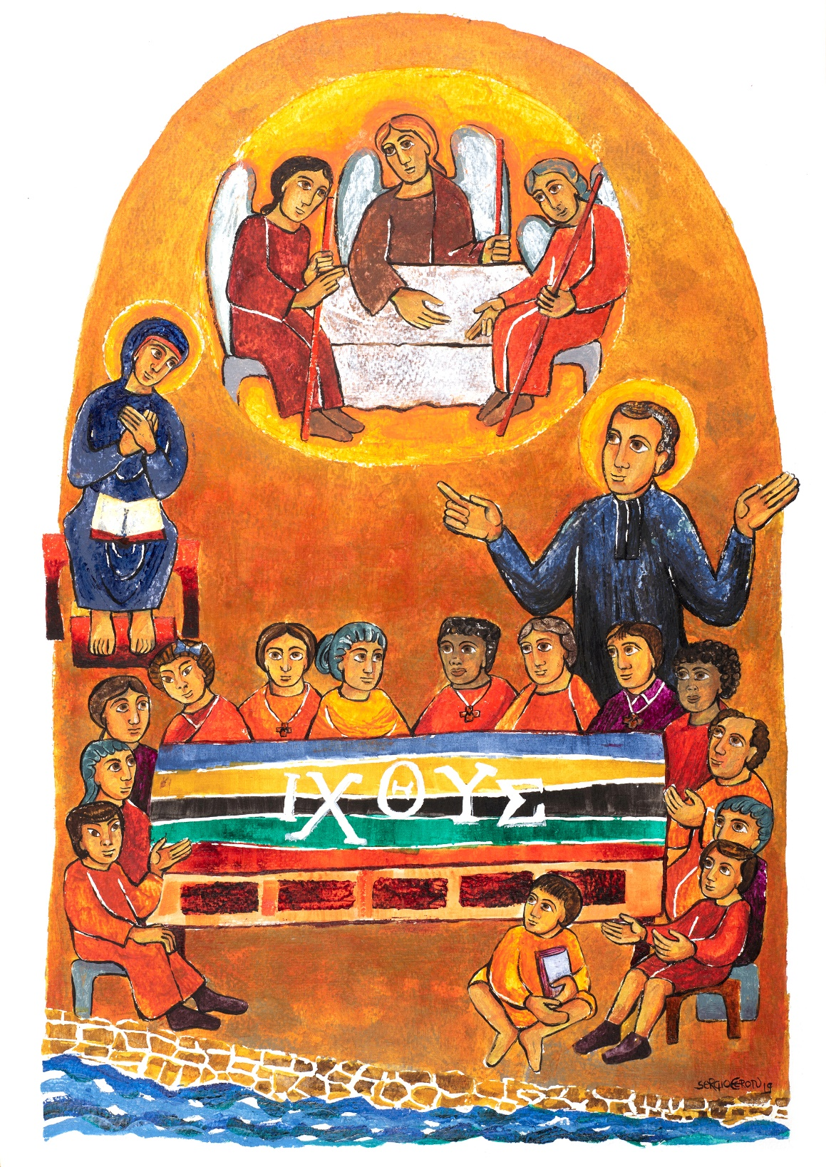

Second Chapter - Section I

Brotherhood as COMMUNION

(A) Contemplating Jesús

“What were you talking about on the way?” (Lk 24:17)

[35] BROTHER,
as you face challenges in community life each day,
never forget that Jesus is among us, here and now.
On the road to Emmaus,
even with the disciples “conversing among themselves” (Lk 24:14),
the Lord was their companion.
He restored their faith and transformed their understanding.

Jesus was present to these two pilgrims;
he listened and shared the Word of God with them.
In time, he broke bread, giving birth to a fraternity
that neither they nor we could have imagined:
a true communion rather than a simple coexistence.

When they discovered the gift that they had received,
rather than stay where they were,
they went in haste to meet the eleven and those with them (cf. Lk 24:33-35).

(B) Brotherhood, the gift that we share

The gift of brotherhood reveals that we are not alone

[36] You discover quickly
that your experience of meeting Jesus and being with him,
while not exclusive, is uniquely different.
Likewise, the mutual acceptance that we experience as brothers
reminds us that we are not alone.
Remember that some of life’s mysteries
are revealed only in the company of others.

A Marist community is one of those places in life
where the mind and heart of God are made manifest.
Jesus is present there, in our midst (cf. Mt 18:20; 28:20),
uniting us in one heart (cf. Acts 4:32; Jer 32:39; Ez 11:19),
pouring out his Spirit upon us (cf. Jn 20:22),
sending us out to announce that in Christ (cf. Mt 28:19; Mk 16:15; Lk 24:47),
we are all brothers and sisters,
children of the same Father (cf. Gal 3:28; 4:6-7).

In our response, we commit ourselves to walk with others

[37] As we become more fully aware that the risen Lord is among us,
in our life and in the life of our community,
we realise that our relationships with our brothers
are deepening, growing richer, being transformed.

Over time our response to the call of the risen Christ matures.
We find our hearts opening to the wider world;
we are moved to share ourselves
and to extend fraternity to others.
In our willingness to walk with them,
we at first adapt our pace to theirs
hoping that over time this experience will quicken their step.

In this way, the face of God
is revealed in fraternal life as communion; ^{(R.38)}
it transforms our relationships
and causes us to put others first, ^{(R.39)}
even when it entails great personal cost. ^{(R.40)}

(C) Your WORD Lord… “I have stored up in my heart” (Ps 119:11)

The brotherhood of God found in communion

[38] The story of Emmaus, with its three characters,
brings to mind other times in Scripture
when God’s presence creates communion in the midst of diversity:
Mambre (cf. Gen. 18: 1f), Nazareth (cf. Lk 2:39-40.51-52),
the Jordan (cf. Mk 1:9f; Mt 3:13f; Lk 3:21f; Jn 1:32f),
Tabor (cf. Mk 9:1f; Mt 17:1f; Lk 9:28f).

God is communion;
we can see that fact reflected in creation;
contemplate all that is good within each of us:
it longs to come together in unity
and strives to build a sense of family, brotherhood, communion.
Because we are one, we are able to accept the rich diversity that exists among us.

Your deepest call in life is to be at one with yourself,
others, God, and all that God has created.
Your vocation as a brother is a meaningful sign
of God’s presence in all people and things.

The motherhood of God

[39] Today, our vision of God is also enriched by a feminine point of view.
We realise that God’s life-giving power is maternal as well as paternal,
and understand that what is boundlessly powerful is God’s love,
nothing can stop God from loving us.
Similarly, like a mother, God’s presence everywhere is full of care and tenderness.
The richness of this new perspective
is becoming more apparent in the Church itself:
the call to promote its Marian face is more and more present.

As a brother, you are called to be an expert in communion.
In the past, this term was sometimes mistakenly framed in hierarchical terms:
the obligation that those below had to those above them.
Living as a brother in community, however, you remind others
that communion implies equality as well as reciprocity.

Your vocation invites you to transform
the relationships that exist in our society and Church.
The new experiences of community that we are creating today
are not only a source of encouragement to others,
they are planting the seeds of a new reality.

The scandal of the incarnation: the transgression of a fraternal God

[40] The God of the Hebrew scriptures was transcendent.
However, rather than cling to divine nature,
out of love, God “became flesh and made his dwelling among us” (Jn 1:14).
God extended communion beyond the confines of the Almighty,
even at the price of the cross (cf. Phil 2,8).
Herein lies the origin of our fraternity:
it is a proclamation of God's salvation for the world.

As you become more generous in your acceptance of others,
you will grow as a brother.
Genuine communion comes about
when you learn to surrender your expectations of others.

So, stop trying to make them over into your own image and likeness.
Instead, allow them to be what they are,
the image and likeness of God (cf. Gn 1:27).

If you do so, gradually, over time,
you will become a brother among your brothers,
as well as to all to whom you are sent: children and young people,
every person who crosses your path, and, ultimately, to the whole of creation.

(D) A contemplative outlook

Look at the love among brothers

[41] Marcellin’s final wish for us
was the same as the mark of the first Christians:
“See how they love one another” (Spiritual Testament, in Life* I, Chapter XXII).

Fraternity is not only the gift that you receive in your vocation,
it is also the one that you share.
For that very reason,
you are called to extend your love to the maximum;
build an ever-expanding universal brotherhood
by committing yourself daily to overcome prejudice
and to fight against indifference.

Strive to give witness to the fact that God is love (cf. 1Jn 4:8)
and that his love is stronger than any of your human limitations (cf. Rom 8:38-39).

Brother, take some time
to contemplate the love that exists among brothers.

Second Chapter - Section II

Consecrated IN community

(A) Contemplating Mary

“She kept all these things in her heart” (Lk 2:51)

[42] BROTHER,
take a look at the home at Nazareth.
Together, Mary, Joseph, and Jesus
were part of a simple and hard-working family.
God’s Spirit, manifest differently in each of them,
transformed that family into an anticipation
of the community made up of Jesus’ disciples.

Mary is both mother and disciple.
“She takes the events of her everyday life into her heart
and reflects upon them” (Lk 2:51).
Day by day, her discipleship is refined;
life’s daily events fail to limit her vision.

She moves beyond the confines of her home
and out into the apostolic community (cf. Acts 1:14).
Her presence there, as a sister in faith,
brings the warmth of a home
to nurture the growth of the community.

(B) Brothers, consecrated in community

A community at home with Mary

[43] BROTHER,
you have come into Marist community
to follow Jesus in the manner of Mary.

Together with your brothers,
you are called to be the Body of Christ,
Living the new commandment of love
with “one heart and mind,”
as was the ideal of the first Christians
and our early brothers (cf. Acts 4:32; Spiritual Testament, in Life* I, Chapter XXII).

Community, though, is expressed mainly through our attitudes.
When you are at home with Mary
and with those who “hear the word of God and live it” (Lk 8:21),
your community is transformed into a new Bethany.
When He was in the company of Lazarus, Martha, and Mary,
Jesus was among friends;
by hosting him in their home
they welcomed the Word of God;
he became for them a source of new life (cf. Jn 11:43).

A community resembling a family with brothers and sisters

[44] Our Marist communities are built upon
a profound covenant of love and of life
that unites you with your brothers
and helps you to overcome your human limitations and prejudices.
To take part in this bond, you must move beyond superficial exchange
and enter into the lives and hearts of your brothers.

Our fraternity is the roof that shelters us;
we strengthen that fraternity to the extent that we can tell our brothers,
“Wherever you go, I will go, and wherever you live, I will live.
Your people will be my people, and your God my God too” (Ru 1:16).

When this covenant is lived fully,
it gives rise to an ever-expanding circle of relationships.
Be open; welcome especially those
who want to live their faith inspired by Marcellin Champagnat.
Come together with these brothers and sisters in a great charismatic family,
centred on Jesus Christ and living in the manner of Mary,
in the service of the mission.

(C) The COMMUNITY… “who built his house on the rock” (Mt 7:24)

Love as an axis

[45] Love should dwell at the heart of our community life.
Work together in building experiences of fraternity
by sharing the gift of yourself and reconciling with your brothers;
that is what love demands of us.

Our brotherhood is meant to demonstrate
that it is possible to live deep relationships
rooted in the love of Christ (cf. Mk 3:34-35; Jn 15:15.17).

Reconcile with your inner self

[46] Along with your personal qualities
that lead to love and help you to build fraternity,
you, like all of us, have tendencies
that can give rise to individualism and rivalry.

You are called to heal your wounds, accept your limits, purify your desires.
Work to overcome selfishness;
purge resentments from your heart (cf. Mt 5:23-24).
The Lord walks with you on this journey of conversion reminding you:
“My grace is sufficient for you;
my strength is shown in your weakness” (2Cor 12:9).

Fraternal dialogue

[47] As you search for God in community,
you must learn to listen as well as to speak.
Fruitful silence opens your heart to your inner self
and leads you to a profound acceptance of others.
Listen to the Spirit found within you and your brothers.

Share the gift of your person.
Foster a style of dialogue that leads to mutual knowledge
and allows you to help others.
Listen before you judge;
learn to see what is essential with the eyes of the heart.

By living in this way,
you will transform your community
into a place where friendship is the norm
and the human and spiritual gifts of each brother
are placed at the service of others (cf. Eph 4:11-12).

Conflicts and growth

[48] Wherever people live together,
tensions and conflicts arise.
This is no less true in a Marist community.
Learn to speak with your brothers
in a manner that is open and transparent.
Doing so will strengthen unity and help you to overcome difficulties. ^{(R.26.56)}

Remember also that refusing
to listen to ideas that make you uncomfortable
will not resolve the matter.
Moving in that direction might serve only
to impoverish everyone or damage, above all,
whomever is most vulnerable at the time.

Never cease reminding yourself
that community is a grace of the Spirit (cf. Eph 4:2-6).
We have come together without choosing one another;
welcome each other as a gift from the Lord.
Remain united in his name, despite your difficulties (cf. Jn 17:11-12).

Fraternal correction and forgiveness

[49] Having experienced God’s unconditional forgiveness,
we learn to forgive each other “seventy times seven” (Mt 18:22).
Actually, we must learn to forgive one another as many times as is necessary.

Likewise, we help each other when we give and receive fraternal advice (cf. Mt 15:17)
In this way, we avoid criticising others or speaking behind their backs.
For fraternal advice to be helpful, however,
you must carefully choose your time to speak
and do so in a manner that is sensitive.

Fraternal communion starts with each of us;
live out this ideal in your own life
and others will do likewise.
Be patient, for building unity takes time;
so, take your time, wait, avoid anxiety,
trust in the slow work of God.

Care of the common house and the community

[50] Together with Marcellin,
our brothers realized that manual labor
was not just something to talk about.
There are lessons to be learned
from working with your hands.
At times, simple labor conveys truths
that words fail to describe. ^{(R.94)}

Like the first brothers,
realise that showing concern
for the care and cleanliness of the house helps to build fraternity.
Demonstrate your commitment to the integrity of creation
and care of the earth by engaging in sound ecological practices
and the careful use of everyday goods. ^{(R.32.33)}

Mutual care and hospitality

[51] Mary, the Virgin of Tenderness,
shows us the way to care for each other
and how to become, over time, marvellous companions to one another.

She reminds you to welcome others, as they are,
different in many ways and yet complementary.
Likewise, she challenges you to nurture a heart
that allows you to recognise when a brother is in difficulty
and to help him in a way that is thoughtful and discreet (cf. Gal 6:1).

Be sure to live hospitality in a way that is welcoming
and gives witness to our universal brotherhood.
Receive warmly, not only the families of our brothers,
but all who come to your door.
In each of them you will meet Christ
who has chosen to call on you;
ensure they all experience the joy of being at home.

Balance in life and community life

[52] Life in common
relies on the contribution of each brother
as well as a sense of balance
among all those elements
that are part and parcel of this way of living.
Although you may live out some of them in a personal way,
the community is still your reference point.

Prayer in common is essential, as are the ministry,
and moments when everyone is together
and there is a chance to share.
Likewise, there needs to be a place
for cultural pursuits, leisure, and household chores,
as well as coming together around a common table
to share daily bread.
All these activities provide us with an opportunity
to put into practice what we profess
and what we are called to live out.

Achieving a sense of balance as a group can be a challenge
but doing so will help you to escape
the tyranny of your own point of view.
Remember the golden rule: “There is an appointed time for everything,
and a time for every affair under the heavens” (Eccl 3:1).

(D) Contemplative listening

Live out fraternity, prayer and life of service in a unified manner

[53] Living community requires you
to engage in a common discernment in your search for God,
to share in the gifts of the Spirit and the material goods of the community,
and to love others without exclusion or exclusiveness.

Born out of the experience of God’s love,
and welcomed with inner freedom,
our Marist brotherhood is the fruit of our trust in God.
It thrives despite the limitations of its members.

Brother, take some time
to listen to the voice of the Spirit
who invites you to live out fraternity,
with your prayer and your life of service,
in a unified and coherent manner.

Second Chapter - Section III

Our way of Marist life

(A) Contemplating Marcellin

The table of La Valla

[54] BROTHER,
the table at La Valla is an icon of our Marist fraternity,
a powerful symbol of the communion that exists
among diverse cultures, peoples, and personalities.

To this table, we bring our human stories,
as well as our concerns, convictions, and dreams.
At this table we share the bread of our lives,
blessed by our common faith in Jesus,
whom we follow in the way of our Good Mother, Mary.

In choosing to sit at this table,
you and I help each other
to become the person that God has called us to be.
From this table, we set forth
to witness to God’s love for all people,
especially children and young people who are most vulnerable.

(B) Fraternal communion lived from a Marist attitude

Family Spirit

[55] The community of the first brothers was a family (cf. Circular to the Brothers, August 12, 1837).
Marcellin often said to its members:
“You know that I live only for you,
that every day I ask God to give you
everything that is genuinely good for you,
and that I would give anything,
even at the cost of the greatest sacrifices,
to procure that for you” (Letter to Brother Denis, Janvier 5, 1838; see also Life* II, Chapter XV).
In return, the brothers loved him like a father (cf. Circular to the Brothers, Janvier 13, 1839).

Marcellin’s vision of fraternity
invites each of us to cultivate a family spirit.
Make it visible by adopting an open heart,
and a willingness to provide help and support,
in community and in ministry.
Strive to create an environment wherein each person
receives the nourishment and encouragement needed.

The little virtues

[56] The Marist tradition invites us to live the Marian virtues
of humility, simplicity, and modesty, symbolized by three violets.
You develop these by practicing the other little virtues
recommended by Marcellin:
listening attentively, being available,
honesty, patience, gentleness, hospitality,
mutual support, courtesy, tolerance,
and service to your sisters and brothers (based on Avis, Leçons et Sentences* Chapter XXVIII). ^{(R.26.48)}

They are your way of living out
the attitudes of Mary of Nazareth,
doing ordinary things
in an extraordinary way. ^{(R.30)}

A strong family spirit,
marked by these little virtues,
is one of the most attractive aspects of Marist fraternal life.
Achieving this end, however, is also ambitious and challenging.
Whether you are young, in midlife,
or near the end of your life’s journey,
strive to persevere with tolerance and humility,
trusting in God’s grace.

(C) The MARIST VOCATION, “With the help of the Holy Spirit, guard this rich trust that dwells within us.” (2 Tm 1:14)

To those who have set out to discern their vocation

[57] In setting out to discern your vocation as a Marist Brother,
you show courage and generosity of heart.
Be patient as you work to integrate your own story
and try not to rush the action of God in your life.

Open your heart to establishing new relationships
and enriching your identity within the Marist community.
Be willing to learn about yourself;
come to know and love Jesus who calls you by name.

With the help of the person guiding you,
awaken to the Spirit’s movement
in your life and in our Marist history.
Take time to appreciate your brothers
and the gift of our Marist charism.

Bit by bit, you will grow to understand just what this vocation,
to be a Marist and a brother, requires of you.
Eventually you will come to know
if this is what God is asking you to do with your life.

To the novice

[58] Value and take full advantage of the privileged time of the novitiate.
First of all, without fear open yourself to God's love;
it is the source and origin of every Christian vocation
and ultimately the only thing that sustains it.

As you are initiated into religious life,
open yourself fully to personal growth
and the process of conversion of heart.
Strive to know and value yourself more deeply
while at the same time integrating the evangelical counsels
and our Marist charism into your way of being and acting.

Learn to cherish silence and the interior life.
Both will help you to grow in intimacy with God
and to develop a deeper love for your brothers and sisters.
Listen carefully to the Spirit of God
who longs to send you into the lives of children and young people;
there you will witness to the love that Jesus has for each of them.

If you decide to welcome God’s call to our Marist life,
and the community agrees,
give yourself wholeheartedly to joyfully living
the vows that you profess as a brother.

To the brother in temporary profession

[59] Share all your energy and enthusiasm,
as well as your dreams and hopes for the future.
Continue to integrate into your life
all that you have learned in formation
about yourself and our way of life.

With the help of your formator and community,
learn to harmonise the personal, community,
and apostolic dimensions of your life
and to balance all three with your prayer, studies, and ministry.
During your time of preparation for mission,
give your studies the importance they deserve.
Together with your formators and those in authority,
prepare carefully for your perpetual profession,
and continue to grow in love and inner freedom
so that you may take this important step joyfully and responsibly.

To the perpetually professed brother

[60] You are a gift of God and a sign of the love
that Jesus and Mary have for our Institute.
Live your journey of consecrated life
with a unity of faith, hope and love.

Like Mary, have a grateful heart.
God is always faithful, trusting in you and telling you,
“Do not be afraid!” (Jgs 6:23; Is 41:10; Lk 1:30).
Go forward each day, step by step,
encouraged by the fidelity of those brothers
who have gone before you.

In your apostolic life,
be a sign of hope for us all,
sharing your generosity and passion for mission
in all its dimensions.
Imitate the young Marcellin Champagnat
by uniting your imagination, enthusiasm, and apostolic zeal
with that of your brothers;
journey together with all who share our Marist charism.

To the middle-aged brother

[61] As the years pass by, you become more self-aware,
your experience deepens and you achieve a certain balance in your life.
By simply being yourself and relying on these gifts,
you become ever more available to be of service
to our Marist fraternal life and mission.

Cultivate an intimacy with the Lord,
be patient and, over time, learn to love your brothers
and others with greater selflessness.
Be generous in sharing your newfound strength
as well as the knowledge that has come with the passage of time.

To the senior brother

[62] You are a living sign of God’s fidelity.
By taking up a positive and constructive attitude,
you transform your years of experience into wisdom
and become a living example of our Marist spirituality
and a grace for your community.

Though less active than in the past,
you remain committed to the mission
through your prayer, and the encouragement you give to your brothers,
particularly those starting out on our way of life.

Never hesitate to offer any service within your reach,
whether in the community or elsewhere;
Continue to cultivate your interest in the life of our Institute,
as well as the Church and world.

To the sick or dying brother

[63] For Marcellin and his early disciples,
a sick brother or one who was dying was a source of blessing;
they loved him until the end of his life (cf. Life* II, Chapter XV).
When you find yourself in either of these situations,
remember that despite moments of discouragement,
the Lord is close to you.
God’s tenderness and compassion make sickness,
suffering, and even death,
a special place of divine presence among us.

In the face of your incapacity, fragility,
and even terminal illness,
draw upon the sacraments as a source of healing,
peace and inner courage.
In these moments, your suffering unites you with Christ’s Paschal Mystery.

Jesus and Mary will comfort and console you;
they will tenderly accompany you to the end
and as you cross over into the next life.
A host of brothers will be waiting for you on the other side
to welcome and embrace you.
You will experience the happiness of dying
as a member of Mary’s family (cf. Life* I, Chapter XXII).

To the brother at any age

[64] Whenever they occur
try to experience moments of doubt,
loss of enthusiasm, dryness of heart,
or a search for false consolations
as God’s invitation to a deeper conversion of heart.

In difficulties and struggles, turn to Jesus and Mary
and seek the support of your brothers, friends,
and others who might be of help.

These experiences, faced honestly and courageously,
often lead to a type of human and spiritual growth
that can hardly be acquired by any other means.
Try not to miss the opportunity offered to you at times like this.
For these difficulties and struggles
will weave into the fabric of your life
a profound understanding about the meaning of fidelity
and its important place in any life lived well.

(D) Prayer

Lord, encourage us on our journey

[65] Good Father,
we are grateful for your company on the journey of life,
you walk with us in faith, hope, and love.

Thank you, Lord,
for calling us to be your disciples.
Confident in your words –”Do not be afraid”–,
we overcome our fears and hesitations
and commit ourselves to following you.

Mary, our Good Mother, we count on you
in moments of doubt and dryness of heart.
Deliver us from the fruitless search for false consolations
and, through your maternal intercession
and the support of our brothers,
help us to overcome all obstacles
and to complete our journey.

Father Champagnat, with your guidance,
we long to advance, step by step,
with hearts full of gratitude,
and encouraged by the witness and fidelity
of those brothers who have gone before us.

Brother, take some time
to proclaim the wonders that the Lord
has brought to life in your brothers and community.

Third Chapter

OUR HEART IN A PERMANENT ATTITUDE OF SERVICE

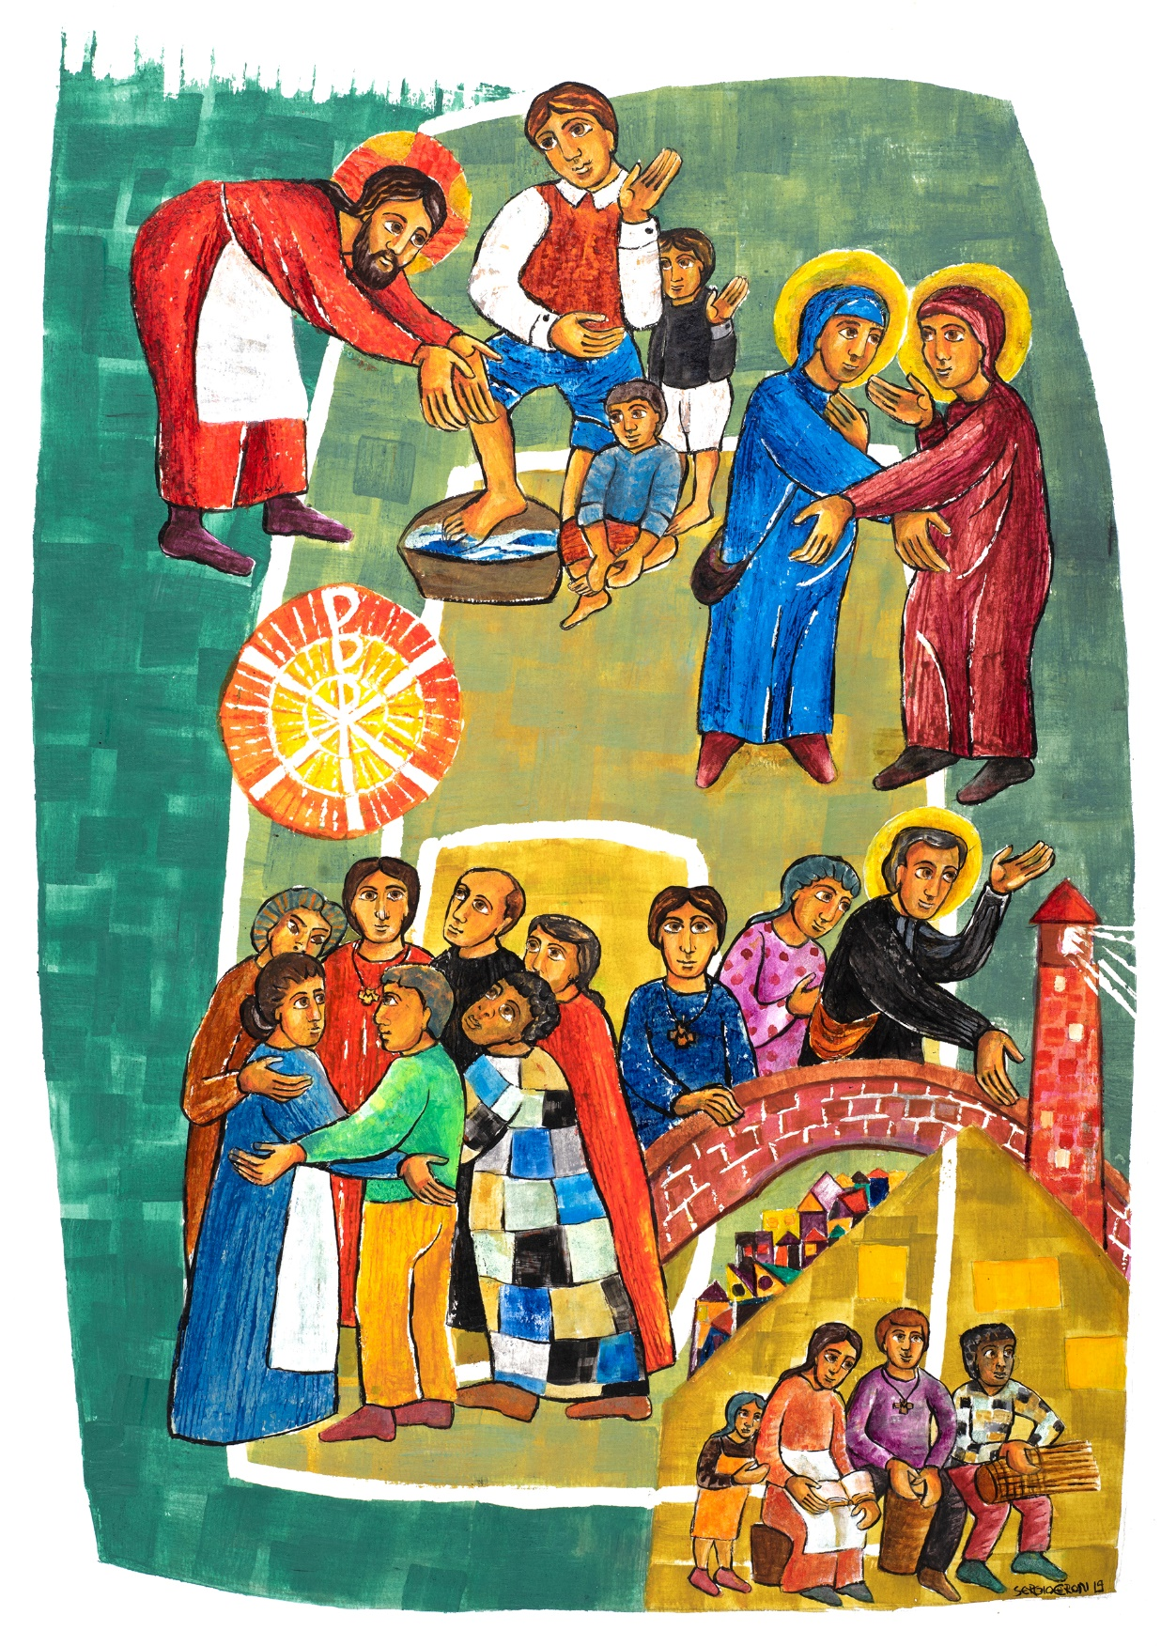

Third Chapter- Section I

Brotherhood as MISSION

(A) Contemplating Jesus

“Wash each other’s feet” (Jn 13:14)

[66] BROTHER,
the icon of Jesus washing his disciples’ feet
reveals the depth of God’s love for humanity.
This simple gesture captures the heart of God’s mission:
the salvation of the world (cf. Jn 3:16-17).

Jesus’ act was revolutionary.
In bending down to wash the feet of others,
the Lord made it clear to everyone
that seeking the privileged place at table
as well as wielding power and dominion over others
was totally unacceptable to God.
Instead, Jesus wants you to be as humble as a little child (cf. Mt 18:4),
last instead of first (cf. Mk 9:35), a servant and brother to all (cf. Mk 9:35; Mt 20:28; Mt 23:11).

In kneeling to wash the feet of his apostles,
the Lord gave us a striking image
of what it means to live his new commandment of love (cf. Jn 13:34).

(B) Brotherhood, the gift that we share

In that gift, your place in the world is revealed

[67] Your experience of being with Jesus,
as well as washing the feet of others,
helps you to understand your place in the world.

We cannot wash the feet of another person
without having to stoop
and approach the common ground
on which we all walk
and to see the world from that vantage point.

When you are in such a place and position,
the words and experiences that you share with others,
as well as those that they share with you,
will be mutually evangelising.
Only by loving like Jesus
will you be recognised as one of his disciples (cf. Jn 13:35).
Let your service to others be humble and generous.

In your response, you put your life into play

[68] Within the fraternal community that welcomes us,
we experience the presence of the risen Lord
as an annunciation and a call to mission.

Like the Lord,
you are called to put yourself at the service of others
and to offer them a tender and self-giving love,
particularly those who are poor and needy.
In following Jesus,
we are meant to love not only those who treat us well
but to wash also the feet of those
who disappoint us, hurt and betray us (cf. Mt 5:43-48; Lk. 6:27-36).

Learn from Stephen and the early deacons.
In the beginning, they served the neglected (cf. Acts 6:1) ^{(R.69)}
within the context of the liturgy, as a ministry. (cf. Acts 6:2). ^{(R.70)}
Their service was such a powerful preaching about the Reign of God
that some wanted it silenced (cf. Acts 6:8-11). ^{(R.71)}
Stephen was the first to follow Jesus
to the end of the cross (cf. Acts 7:54-60);
his courage is evident
in the lives of our martyred brothers.

(C) Your WORD Lord… “gives me life” (Ps 119:50)

Fraternity, at the heart of God’s mission

[69] You are meant to be, first and foremost,
an agent of the mission of God,
a living memory of the Good News of Jesus of Nazareth.

By his words and actions,
Jesus establishes communion
with all those who find themselves on the margins of life;
he identifies with them (cf. Mt 25:40.45).
Christ’s compassion makes it clear that
brotherhood is an important dimension of the mission;
God does not save us in isolation from others.

When you are truly a brother
to those who are poor and powerless,
you manifest the fraternal dimension
of God’s saving power (cf. Mt 25:40.45; Mk 10:14-16).

May your brotherhood move you
to commit yourself to the causes
of those who are the least, the last, and the lost.
In that way, you carry on the liberating action of Christ
and make it evident in today’s world (cf. 1Jn 1:1-2).

Fraternity, a ministry in the Church

[70] Your chief contribution to the life of the Church
is to be on mission as brother.
Your vocation itself is a ministry within the Church;
a reminder to the wider community
about the importance of fraternity
and our fundamental call to be
a community of brothers and sisters in service (diakonia).

At the banquet in the Reign of God,
a brother takes his place as one who serves the table,
caring especially for those thought to be most insignificant.

By putting on the apron of brotherhood,
your specific vestment in the liturgy of life,
you join your service to the mission of God.

Fraternity, a living parable of God’s Reign

[71] May the story of your life
be a “living parable of brotherhood,”
that makes known the Reign of God
among your sisters and brothers.
Live your brotherhood with simplicity.
Your primary mission is to be a brother
and to promote brotherhood.

Be inspired by Jesus of Nazareth,
a mighty prophet of word and deed (cf. Lk 24:19).
Because he lived what he preached,
his authority went unquestioned (cf. Mk 1:22.27; Mt 23:2-3; Lk 4:32-36).
A herald of God’s mercy,
his entire life became a visible parable of God’s Reign.

Your service within the ecclesial community or other organizations
appears to be as tiny as a mustard seed (cf. Mk 4:31-32)
but is a genuine announcement of Christ and his Reign.

(D) A contemplative outlook

Look at God’s love for our world

[72] Put aside your worries, problems, doubts,
and simply look at the world around you, both near and far.

Take note of the needs of so many
as well as the suffering they experience.
Attend particularly to those often overlooked
or thought to be most inconsequential:
poor children and young people.

Linger briefly with this last group
and begin to look at the world through their eyes, the eyes of poor children.
Doing so, will draw you closer to what God sees and loves.
Nothing but that love can transform our world.

Brother, take some time
to contemplate God’s love for our world.

Third Chapter - Section II

Consecrated FOR mission

(A) Contemplating Mary

“Mary went as quickly as she could into the hill country” (Lk 1:39)

[73] BROTHER,
together with your fellow Marists,
let yourself be inspired by the icon
of Mary’s visit to her cousin Elizabeth (cf. Lk 1:39-56).
This event will help you to appreciate Mary as a disciple:
our sister in mission.

Be concerned with the needs of others rather than your own,
and go in haste to share the Good News,
always seeking out those who are dispossessed and marginalised
and inviting them to take their place at the banquet in the Reign of God (cf. Lk 1:53).

Rejoice with those who feel unworthy of the attention of others,
“Who am I that the mother of my Lord should come and visit me?” (Lk 1:43).
Learn to sing with them of the greatness of the Lord
and to proclaim his salvation,
“My soul magnifies the Lord” (Lk 1:46).

(B) Brothers, consecrated for mission

A mission in the service of children and young people

[74] Inspired by Marcellin,
in his encounter with the dying boy,
open your heart to the joys and hopes
as well as the sufferings and challenges
of those most in need of the loving, healing, reconciling presence of God.

More specifically, as a Marist Brother,
you are sent by the Church,
on behalf of our Institute,
to be an apostle to youth,
and a sower of hope among children and young people.

A mission to evangelise by educating

[75] As an apostle to youth, Marcellin’s experience of God's love
led him to say: “I cannot see a child without wanting to teach him the catechism
and to tell him just how much Jesus Christ loves him.” (Life* II, Chapter XX).

Love is the key to our approach to education and evangelisation.
Through the respectful love that you offer to children and young people,
they come to discover how much God loves them.

Marcellin said to his brothers, “To educate children properly,
you must love them first and love them all equally” (Life* II, Chapter XXIII).
By doing so, you help them to become
“good Christians and good citizens” (Letter to Mr Libersat, September 19, 1839).

Through your dedication,
you try to respond to the needs and expectations of today’s young people.

(C) The MISSION... “draws from its treasure things new and old” (Mt 13:52)

Evangelisers in the style of Mary

[76] Mary teaches you how to be an apostle and evangeliser.
Live out her attitudes in your own life
and work to make her, our Ordinary Resource, known and loved.
By your example, you help others to understand
that she is the way to Jesus:
“All to Jesus through Mary, all to Mary for Jesus” (Life* II, Chapter VII).

As a Marist Brother
you are meant to be a leaven within our Church,
promoting its Marian face
and making it more participatory and prophetic.

Never stop sharing your passion for God
as well as your love for Jesus, Mary, and Marcellin.
By your life, give witness to the way in which our Marist charism
inspires and promotes your evangelising presence in the world.

Focus on inclusive education

[77] As Marists, we offer an education
that helps young people to integrate life, faith, and culture.
Consequently, we choose to make our ministries
forums of human development and evangelisation
that promote a committed, compassionate,
inclusive, and transforming experience of learning.

As one who shares in that mission,
work to advance intercultural and interfaith dialogue
as well as respectful and enriching relationships
between cultures and religious traditions.

Commit yourself to the work of solidarity
and of social and ecological transformation,
and invite others to join you in these efforts.

Promoting and defending the rights of children

[78] The trust that has been placed in you
by the children and young people in your care
is a special privilege and a serious responsibility.

Honour that confidence
by showing great respect toward each of them
and protecting them from anything that could harm them.

United together with other people and institutions
denounce those structures that oppress them.
Defend their dignity and rights,
especially when they are under attack.

Participation and collaboration

[79] Never hesitate to promote participation and collaboration in mission;
both strengthen teamwork
and foster family spirit and cooperation.
Join others in supporting the creation and strengthening of networks
linked to our Marist mission.

Doing so enhances communication in all areas
and collaboration with other social and Church organisations.
Though you may have many resources on-hand,
remember that no one is self-sufficient;
each of us has something to learn and to contribute.

In continuous discernment of the mission

[80] United with other Marists,
listen carefully to what God is telling you
through the needs found in our world,
the calls of the Church, and the priorities set by the Institute.

Encourage and support efforts aimed at discerning
our Marist mission for today and evaluating it periodically.
Failing to do so might allow you and others to remain undisturbed
but that is hardly the formula for pastoral and missionary conversion.

Through prayer and in person,
support periodic initiatives aimed at assessing
our Marist response to the signs of the times.

Developing a global availability

[81] Attentive to the movements of the Spirit,
and open to the needs of our world,
listen with your heart to the call
to go out continually as a brother on mission.

With boldness and creativity,
look for new ways to respond
to the emerging needs of today’s world.
With your brothers and other Marists,
prepare to go to those places
where your presence is needed the most.

Mary was a woman with a sparkle in her eye
and two feet planted firmly on the ground.
Today, she invites you to go to those places
where others will not.

Open to interculturality

[82] Along with your brothers and other Marists,
strive everywhere to be a mediator of the Good News of Jesus Christ
and an agent of transformation.

Wherever you find yourself living,
respect and be sensitive to the customs, values, and beliefs of local people.
At the same time,
be aware of and thankful for the ways in which the Spirit
is already present in their life and traditions.
Work to purify your own culture
and to help others to see how they might do the same with theirs.

By living in international and intercultural communities,
you witness to the richness of cultural diversity and differences among peoples.
Be patient when discerning an appropriate response to the needs of people.

(D) Contemplative listening

Live the Marist mission with all of its inspiration and challenge

[83] Mission has more to do
with the way in which you live
rather than with anything that you might do.
As you grow in this area,
your whole life becomes “mission”;
not just what you do as a task.

Following the example of Father Champagnat,
put all your trust in the Lord:
"I will dare to say that as long as God does not abandon me -may his holy name be blessed- I am not afraid of anything” (Letter to the Vicar General of the Diocese of Lyon on May 1827).
Entrust to him all the joys, hopes, anxieties and doubts
that are so much a part of your mission.
Have confidence in Mary also;
as our Good Mother, she has done everything for us.

Brother, take some time
to listen to the voice of the Spirit
that invites you to live the Marist mission
with all of its inspiration and challenge.

Third Chapter - Section III

Our paths of Marist mission

(A) Contemplating Marcellin

Heart of a mother and a good shepherd

[84] BROTHER,
recall that Laurent, François, Stanislas, Sylvestre,
and the other members of the first Marist community,
held close to their hearts the memory of Marcellin
as a father who cared for them like a mother.
He worked hard, sparing no effort, in his priestly ministry
and in accompanying his brothers and communities.

The Founder rolled up his sleeves, hitched up his soutane
and with determination cut the stone needed to build the Hermitage.
He was a tender leader who was straightforward, firm, and equitable.

Important decisions were entrusted to God;
Marcellin prayed and reflected
as he sought to know God’s will
and to apply it to his present situation.
He always acted in collaboration with his brothers.

(B) The mission lived from Marist attitudes

The pedagogy of presence

[85] Go out to meet children and young people where you find them.
Draw close to them, taking an interest in their lives
and welcoming them into yours.
Journey with them in their struggles, their searching, their suffering.

Be a brother to each of them: close, accessible, human.
You will win their confidence by your attentive and hospitable presence;
create a climate that facilitates dialogue in their education
and integration in their personal growth.

Love of work

[86] A love of work is one of the distinguishing characteristics
of our Marist way of life and our approach to education.
This quality develops and matures in you
when you come to see the fruit of your labour
as a gift from God.

Beware of an activism that casts aside gospel values
in favour of a self-seeking success.
Harmonize your efforts in ministry
with your life of prayer and in community.

Your balanced approach to living illustrates
to the children and young people entrusted to your care
the true meaning of love of work.

(C) The MARIST MINISTRY, “fulfill the ministry that you have received in the Lord” (Col. 4:17)

To the brother in a community

[87] In both community and mission,
strive to be attentive to the Spirit.
Share the gifts that God has given you
by bringing your competence and creativity
to your life with your brothers and your daily ministry.

Acknowledge the responsibilities that have been given
to those who exercise leadership;
in a spirit of communion, cooperate with them
as they work to guide you in your life and mission.
In a spirit of faith, accept their mediation
as you search for God’s will.

To the brother engaged in active ministry

[88] Brother, regardless of your age or ministry within the Institute,
make of your life and the work that you do a prophetic sign of God’s Reign.

Realise that in taking up the tasks that have been given to you,
you participate in the mission of Christ.
This service complements the efforts
of the other members of the ecclesial community.

Never forget that you are sent on mission
as a sign of God’s maternal tenderness
as well as the fraternal love that we share in Christ.
Live it with passion
and be a reason for hope among those to whom you are sent.

To the brother involved in youth ministry

[89] Accompanying young people in a Marist setting
or in the life of the local Church
gives you an opportunity to imitate the example of Marcellin
by being an exceptional witness
to the action of the Spirit in each new generation.

Cultivate a positive outlook
while also remaining open to offering a challenge when necessary.
Educate yourself about their world with its emerging trends,
demonstrating both empathy and a critical eye.

Accompany young people in their experience of faith
and in the discernment of their vocation.
Encourage them to become both prophets
and instruments of evangelisation to their own generation.

To the brother serving as formator

[90] Your mission of helping aspirants, postulants,
novices, and young brothers to discern their vocation
is crucial for the life of our Marist community.

Share with each of them your passion for this way of life
and the depth of your Marist spirituality,
as well as your personal gifts and abilities and experience of faith.
Care for their well-being, foster their growth,
be patient and discreet with each of them.

Never forget that the Spirit of God
is the true formator of those entrusted to your care.
Look to Mary and Marcellin as sources of inspiration.
In your zeal to be of service,
don’t overlook your personal well-being
as a Christian and religious person,
particularly your need for ongoing formation.

To the brother who is a community leader

[91] When you are asked to take up the service of leadership,
follow the example of Christ
by serving your brothers with simplicity.
Be the first in obedience
and invite your brothers to build a fraternal community
that seeks and loves the Lord in the manner of Mary.

Be alert to the movement of the Spirit
in yourself and in your brothers.
Listen to them, encourage them,
and discern with each of them how they can respond faithfully
to what the Lord is asking of them.

Encourage your brothers to put together a Community Plan
that fosters a charismatic vitality.
Be an example of the possibility of conversion rather than of perfection.
With humility, recognize your own limits and your need for others.
Don’t expect miracles, either from yourself
or from those for whom you have responsibility;
rather, be patient, admit that only the Spirit of God can change hearts.

To the brother responsible for a ministry

[92] When you are asked to take up the service of leadership
in a work or ministry within or outside of the Institute,
promote those Marist characteristics and values
that are a true expression of our charism.

Create a safe environment that promotes trust and collaboration.
Give preference to those who are often overlooked;
pay special attention to young people
and participate actively in developing their leadership skills.

To the brother bursar in a community or ministry

[93] Manage all the goods entrusted to your care
with human sensitivity and professional skill,
without losing sight of religious and apostolic priorities.
Help your brothers and all who share in our Marist life and mission
to feel as though they are members of a family.

Be a humble servant to your brothers in community
as well as in any work of the Institute that has been entrusted to you.
Be discerning and generous as you put available resources
at the service of the mission;
combine a healthy prudence with a bold confidence in Providence.

To the brother in internal or manual tasks

[94] Your selfless service
is fully a part of the Institute’s apostolate.
Working in a manner that is often quiet and inconspicuous,
you model for all of us the image of Jesus washing the feet of his disciples
and Mary when visiting her cousin Elizabeth.

The simplicity and generosity with which you perform your duties
are a daily reminder to us about the true nature of our brotherhood.
Rest assured that your life and efforts
resonate loud and clear,
challenging so many to reflect
on the meaning of our fraternity. ^{(R.50)}

(D) Prayer

Lord, help us surrender

[95] Ever faithful God,
we are grateful in a special way
for the charism received through Marcellin Champagnat.
It has enriched the life of the Church
and continues to do the same in the lives of so many Marists today.

Thank you for the many generations of Marist Brothers,
who, in serving all around the world,
have given their lives for the evangelisation of children and young people.

Thanks, too, for the growing number of others called to be Marist,
men and women called by the Spirit
to live their Christian vocations as Marists,
in communion with their brothers,
and sharing together the one same mission.

We are grateful also for the presence of the Spirit
who calls us constantly to be converted anew,
and who never ceases to surprise us
by opening new horizons within the Institute.

Grant us courage and generosity
so that we may be signs of your mercy and tenderness
among the poor young people of today.
May we be faithful to our mission
of making Jesus Christ known and loved.

Mary, woman of action,
make our hands and feet move 'in haste' to others,
bringing them, as you did,
the charity and love of your Son Jesus
and the light of the gospel to the world.
Amen.

Brother, take some time
to proclaim the wonders that the Lord has brought about in your mission
and in the lives of the people who share it with you.

Doxology and invocations

Glory be to the Father, and to the Son, and to the Holy Spirit;
as it was in the beginning, is now, and ever shall be,
world without end.
Amen.

Mary, Our Good Mother, pray for us!
Saint Marcellin Champagnat, pray for us!

In the name of the Father, the Son, and the Holy Spirit.
Amen.

BIBLIOGRAPHY (ENGLISH)

Letters*

Brother Paul Sester (ed), Letters of Marcellin J.B. Champagnat 1789-1840. Vol. 1: Texts, Rome, Casa Generalizia dei Fratelli maristi, 1991 (Tipografia Citta Nuova della P.A.M.O.N, Roma, 1992).
Translated by Bro Leonard Voegtle.
Source text:
Frère Paul Sester (ed), Lettres de Marcellin J. B. Champagnat 1789-1840. Vol. I: Textes, Rome, Casa Generalizia dei Fratelli maristi, 1985 (Scuola Tipografica S. Pio X, Roma).

Life*

Brother John-Baptist (Jean-Baptiste Furet), Life of Joseph Benedict Marcellin Champagnat (Bicentenary Edition ) Rome, General House, 1989.
Translated by Ludovic Burke.
Source text:
Frère Jean-Baptiste (Jean-Baptiste Furet), Vie de Joseph-Benoît-Marcellin Champagnat (Édition du Bicentenaire), Rome, Maison Généralice des Frères Maristes, 1989 (Tipografia Citta Nuova della P.A.M.O.N, Roma).

Avis, Leçons et Sentences*

Brother John Baptist (Jean-Baptiste Furet), Opinions, Conferences, Sayings and Instructions of Marcellin Champagnat, Rome, General House, 1993.
Translated by Leonard Voegtle
Source text:
Frère Jean-Baptiste (Jean Baptiste Furet), Avis, Leçons, Sentences et Instructions du Vénérable Père Champagnat, Lyon-Paris, Ed. Librairie Catholique Emmanuel Vitte, 1927.

TABLE OF CONTENTS

WHEREVER YOU GO
A Marist Brother’s Rule of Life

INVITATION

First Chapter
OUR VOCATION: BEING BROTHER

First Chapter
SECTION I: Brotherhood as a MYSTERY

(A) Contemplating Jesus
- [1] “Master, where do you live? Come and you will see” (Jn 1:39)

(B) Brotherhood, the gift that we receive
- [2] In this gift, the origin of your vocation is revealed
- [3] In your response, the essence of your vocation is expressed

(C) Your WORD Lord… “a lamp to my feet and a light to my path” (Ps 119:105)
- [4] Brotherhood, a partnership for the Kingdom
- [5] Brotherhood, a prophecy for the world
- [6] Brotherhood, a sacramental sign in the Church

(D) Contemplative outlook
- [7] Look at God’s unconditional love for you

First Chapter
SECTION II: Consecrated BY God

(A) Contemplating Mary
- [8] "Let it be done unto me according to your Word" (Lk 1:38)

(B) Brothers, consecrated by God
- [9] A God with a human face in Jesus
- [10] A God who calls for hope

(C) The EVANGELICAL COUNSELS …” for the sake of the Kingdom of Heaven” (Mt 19:12)
- [11] Following Jesus, in the style of Mary, together with Marcelin, as consecrated men

- Celibate chastity, “Loving with tenderness” (Mic 6:8)
- [12] Conscious of the meaning of evangelical celibacy
- [13] Diligent in cultivating evangelical chastity
- [14] Attentive to your limits in the experience of evangelical celibate chastity

- Obedience, “Walking humbly with your God” (Mic 6:8)
- [15] Conscious of the meaning of evangelical obedience
- [16] Diligent in cultivating evangelical obedience
- [17] Attentive to your limits in the experience of evangelical obedience

- Poverty, “Practicing justice” (Mic 6:8)
- [18] Conscious of the meaning of evangelical poverty
- [19] Diligent in cultivating evangelical poverty
- [20] Attentive to your limits in the experience of evangelical poverty

(D) Contemplative listening
- [21] Live the evangelical counsels fully

First Chapter
SECTION III: Our Marist spiritual pathway

(A) Contemplating Marcellin
- [22] The altar used by Marcellin

(B) The mystery of living out a Marist contemplative attitude
- [23] The presence of God
- [24] The three first places

(C) The MARIST SPIRITUALITY, “to fan into flame the gift of God, which is in you” (2 Tm 1:6)
- [25] Water from the rock
- [26] A spirituality of simplicity
- [27] Called to be a mystic
- [28] In the house of Mary
- [29] Incarnating the Word
- [30] An extraordinarily ordinary life
- [31] Walking with others
- [32] The causes that bind us
- [33] Awakening conscience

(D) Prayer
- [34] Lord, quicken our spirit

Second Chapter
OUR WAY: LIVING IN COMMUNITY

Second Chapter
SECTION I: Brotherhood as COMMUNION

(A) Contemplating Jesus
- [35] “What were you talking about on the way?” (Lk 24:17)

(B) Brotherhood, the gift that we share
- [36] The gift of brotherhood reveals that we are not alone
- [37] In our response, we commit ourselves to walk with others

(C) Your WORD Lord… “I have stored up in my heart” (Ps 119:11)
- [38] The brotherhood of God found in communion
- [39] The motherhood of God
- [40] The scandal of the incarnation: the transgression of a fraternal God

(D) Contemplative outlook
- [41] Look at the love among brothers

Second Chapter
SECTION II: Consecrated IN community

(A) Contemplating Mary
- [42] “She kept all these things in her heart” (Lk 2:51)

(B) Brothers, consecrated in community
- [43] A community at home with Mary
- [44] A community resembling a family with brothers and sisters

(C) The MARIST COMMUNITY… “who build his house on the rock” (Mt 7:24)
- [45] Love as an axis
- [46] Reconcile with your inner self
- [47] Fraternal dialogue
- [48] Conflicts and growth
- [49] Fraternal correction and forgiveness
- [50] Care of the common house and the community
- [51] Mutual welcome and hospitality
- [52] Balance in life and community life

(D) Contemplative listening
- [53] Live out fraternity, prayer and life of service in a unified manner

Second Chapter
SECTION III: Our way of Marist life

(A) Contemplating Marcellin
- [54] The table of La Valla

(B) Fraternal communion lived from a Marist attitude
- [55] Family Spirit
- [56] The little virtues

(C) The MARIST VOCATION, “by the Holy Spirit, guard the good deposit entrusted to you” (2 Tm 1:14)
- [57] To those who have set out to discern their vocation
- [58] To the novice
- [59] To the brother in temporary profession
- [60] To the perpetually professed brother
- [61] To the middle-aged brother
- [62] To the senior brother
- [63] To the sick or dying brother
- [64] To the brother at any age

(D) Prayer
- [65] Lord, encourage us on our jouney

Third Chapter
OUR HEART: IN A PERMANENT ATTITUDE OF SERVICE

Third Chapter
SECTION I: Brotherhood as MISSION

(A) Contemplating Jesus
- [66] “Wash each other’s feet” (Jn 13:14)

(B) Brotherhood, the gift that we share
- [67] In that gift, your place in the world is revealed
- [68] In your response, you put your life into play

(C) Your WORD Lord… “gives me life” (Ps 119:50)
- [69] Fraternity, at the heart of God’s mission
- [70] Fraternity, a ministry in the Church
- [71] Fraternity, a living parable of God’s Reign

(D) Contemplative outlook
- [72] Look at God’s love for our world

Third Chapter
SECTION II: Consecrate FOR mission

(A) Contemplating Mary
- [73] “Mary went quickly as she could into the hill country” (Lk 1:39)

(B) Brothers, consecrated for mission
- [74] A mission in the service of children and young people
- [75] A mission to evangelise by educating

(C) The MARIST MISSION... "draws from its treasure things new and old" (Mt 13:52)
- [76] Evangelisers in the style of Mary
- [77] Focus on inclusive education
- [78] Promoting and defending the rights of children
- [79] Participation and collaboration
- [80] In continuous discernment of the mission
- [81] Developing a global availability
- [82] Open to interculturality

(D) Contemplative listening
- [83] Live the Marist mission with all of its inspiration and challenge

Third Chapter
SECTION III: Our paths of Marist mission

(A) Contemplating Marcellin
- [84] Heart of a mother and a good shepherd

(B) The mission lived from Marist attitudes
- [85] The pedagogy of presence
- [86] Love of work

(C) The MARIST MINISTRY, “fulfil the ministry that you have received in the Lord" (Col 4:17)
- [87] To the brother in a community
- [88] To the brother engaged in active ministry
- [89] To the brother involved in youth ministry
- [90] To the brother serving as formator
- [91] To the brother who is a community leader
- [92] To the brother responsible for a ministry
- [93] To the brother bursar in a community or ministry
- [94] To the brother in internal or manual tasks

(D) Prayer
- [95] Lord, help us surrender

DOXOLOGY AND INVOCATIONS

(*) Pope Francis uses this expression of Italian bishop Tonino Bello (+1993) when recalling that the only vestment that Jesus ever wore in the gospels was the towel with which he girded himself when washing the feet of his disciples (cf. Jn 13:1-15). The apron of the Church is service, mercy and tenderness.

