Mary,
first disciple of the Lord,
we thank you for the group of priests,
Champagnat and Colin among them,
who consecrated themselves to you
in Fourvière 200 years ago,
committing themselves to renew the Church,
inspired by you and under your protection.

Thank you for the Marist Family,
at present extending to all parts of the world,
heir of that dream of the first Marists.
It desires, today like yesterday,
to place itself at the service of our brothers and sisters,
especially those who live
in situations of greater vulnerability.

Thank you in a special way,
for the Charism received
through Marcellin Champagnat,
who, on so many occasions, travelled to Fourvière
to entrust his projects to you
and abandon himself into your hands.

Aware that
You always do everything among us,
we thank you for so many generations
of Marist Brothers who, on the five continents,
gave their lives
to the evangelization of children and young people.
Thank you for the growth of the Marist Laity,
women and men called by the Holy Spirit
to live their Christian vocation as Marists,
in communion with the Brothers,
and sharing one same mission.

All of us,
Marists of Champagnat,
entrust ourselves to you, our good Mother of Fourvière,
pilgrim of faith.
With daring and generosity,
may we be signs of your tenderness and mercy
among the Montagne of today,
and may we be faithful to our mission
to make Jesus Christ known and loved.

Amen.

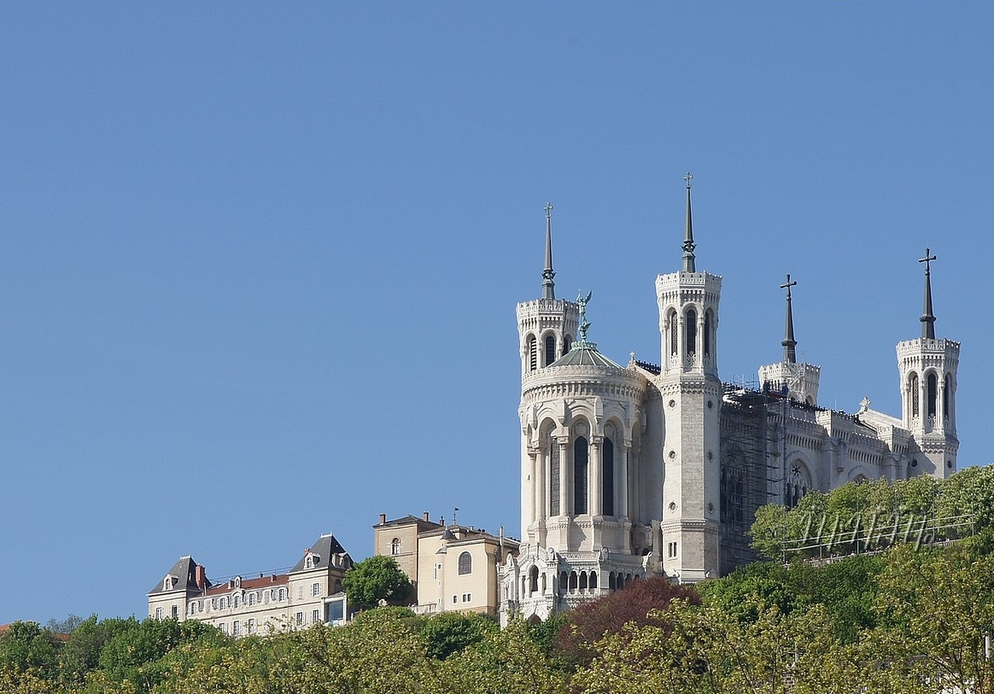
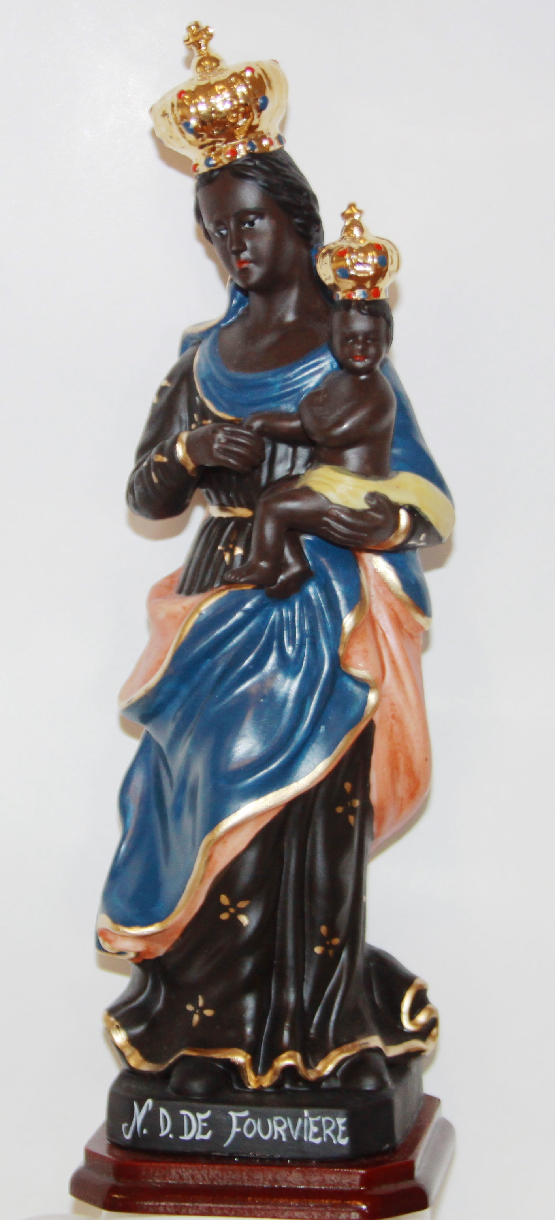
PRAYER
for the Year of Fourvière

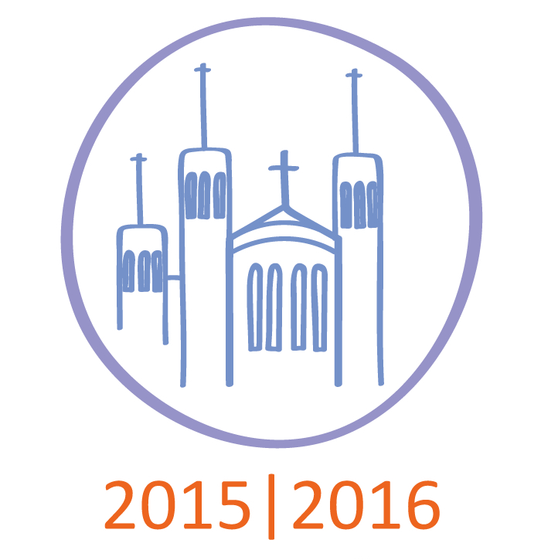
Oración para el Año Fourvière

