Only wonder knows
Christmas Message 2012 of Br Superior General
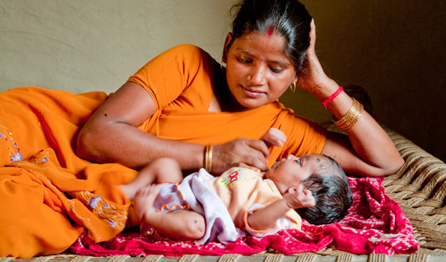
Many of us, probably, at one time or another in our lives, have had an experience similar to the one G. K. Chesterton describes in his Autobiography: “At the back of our brains, so to speak, there was a forgotten blaze or burst of astonishment at our own existence. The object of the artistic and spiritual life was to dig for this submerged sunrise of wonders; so that a man sitting in a chair might suddenly understand that he was actually alive, and be happy.” At any given moment every-thing appears tedious and ordinary, and only an instant later everything is seen as extraordinary and marvelous. It is as though you found yourself struck by a sudden attack of wonder, which arouses humility and gratitude before the miracle of life.
Is not this the experience of parents faced with the birth of a child? Words are insufficient to express this very personal experience, and so we must have recourse to art. The popular saxophonist Kenny G. launched Miracles shortly after the birth of one of his children, and something similar happened with Céline Dion, with her disk Miracle, which was inspired by the birth of her first child.
Human reproduction is a very natural phenomenon, but the artists mentioned experience it as a miracle. It is as if they wake up to see reality with new eyes; as if they see for the first time things which have always been there. A profound conviction emerges that the generation of a new human life is something mysterious, although everything can be explained on the level of biology. And before the mystery, only silent contemplation is adequate. As mothers do in long hours of silence, full of wonder, before the frailness of a new human being.
It is not difficult, this Christmas, to imagine the amazement of Mary and Joseph, surprised at discovering that life is more than life, that there is always something that transcends us in the ordinary framework of our story. A learning that they then carry on for the length of their lives, marked, like that of many of their contemporaries, by moments of serenity and peace, but also by others of extreme violence.
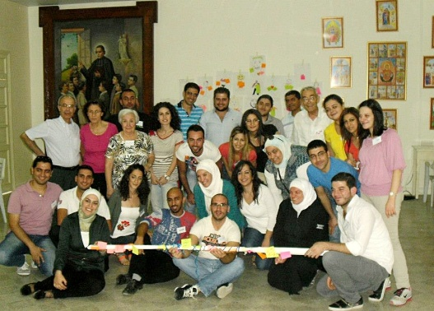
A learning that the 3 brothers of our community in Aleppo, Syria, some 600 km from Bethlehem, have also been having. For some months, the civil population of this ancient city has found itself immersed in a situation of fierce violence: armed struggle, bombardment, lack of resources... The surprising thing is how, in such adverse circumstances, even here wonder can flower.
In fact, we are struck with deep admiration before the situations developing, in unexpected ways: a group of lay Marists who, defying fear, commit their time and capabilities to be beside the most vulnerable victims, without distinction of culture or religion; the collaboration of Moslem volunteers uniting with the Maristes bleus; the spontaneous laughter of the children, at least for a few hours; the network of solidarity that has been woven, on the local as well as the international level… Yes, hope is possible. Although everything appears to show that violence and death have the last word, modest hope, as Péguy called it, persists in holding firm in the hearts of simple people.
How can we continue to support the hope of our brothers and sisters in Aleppo? I invite you to place a candle in some special place in your community or home between 18 and 25 December and light it each day at a particular time, as a symbol of our communion with them through our affection and prayer.
Gregory of Nyssa, a Christian bishop who lived at the end of the IV century in this same region of the Middle East, wrote that concepts create idols; only wonder knows. Yes, concepts create idols and often misunderstandings leading right up to war. Only wonder is capable of penetrating reality as it appears to our eyes, and embracing the happiness of a full life, even amidst the most adverse conditions.
This is what I want to say when I wish you happy Christmas.
May it be truly so for you and yours.

