Prayer for vocations 17/02

Motivation. Circular "Vocations" - H. Charles Howard
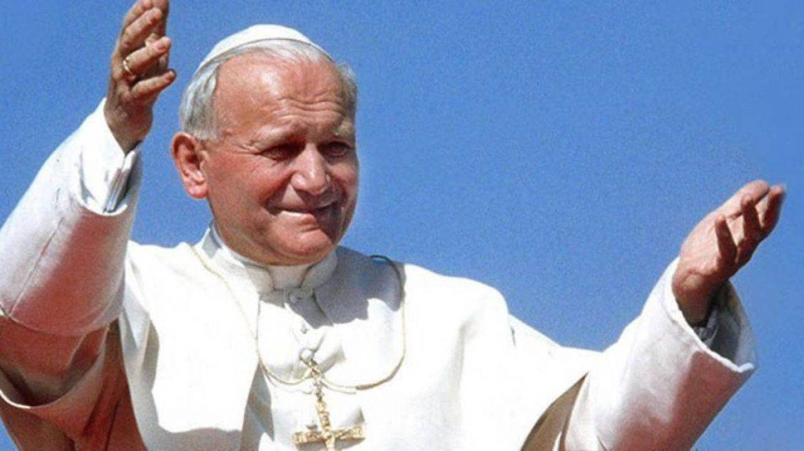
"The idea of an exclusive surrender to God can only germinate in a heart that prays" (John Paul II).

A vocation awakens and grows in an atmosphere of prayer. Only in prayer, which is openness, listening and active acceptance of the Word, do I become aware of the call and the relationship to which God invites me. Authentic prayer helps me to understand my own self, my own identity and the meaning of my mission in life.

From this derives the evident need to nourish the life of prayer in all those who are seeking meaning in their lives, of those who will perhaps be called. A vital aspect of the pastoral care of vocations consists in helping young people to develop their life of prayer. A response to a call will always be the fruit of prayer, of a spiritual experience. This must be an essential concern in vocation work.

Our vocation is not just to be teachers. We are not looking for young people who want to work for youth as teachers or in any other way. We must be attentive to those who wish to follow Jesus Christ as consecrated men, and whose mission will be to work in the service of young people. The spiritual experience is always the most important. Pope John Paul II said to religious some years ago: "People know you and appreciate you for what you do, but your true value comes from what you are. It is possible that, at times, we too forget this.

GOSPEL MATTHEW 9

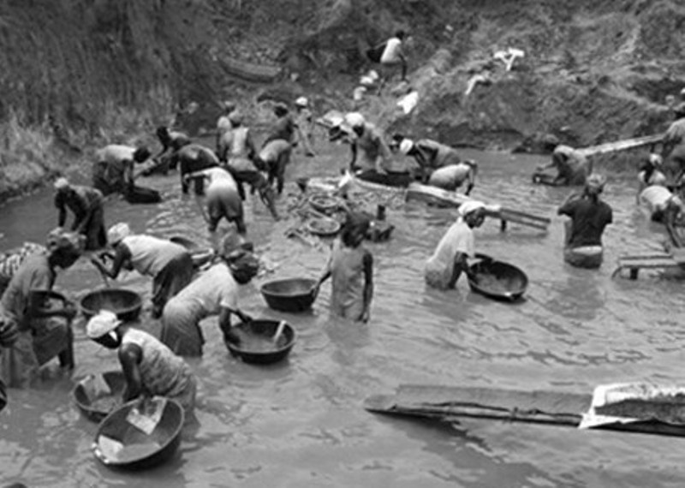
- And Jesus went about all the cities and villages, teaching in their synagogues, and preaching the gospel of the kingdom, and healing every sickness and every disease among the people.

- And when he saw the multitudes, he had compassion on them; for they were forsaken and scattered, as sheep having no shepherd.

- Then he said to his disciples, "The harvest is plentiful, but the laborers are few.

- Pray therefore the Lord of the harvest to send out laborers into his harvest.

PSALM 138
R/ Jesus, give us vocations according to your heart.
Lord, you probe me and know me;
you know me when I sit down or stand up,

from afar you penetrate my thoughts; you distinguish my path and my rest,
all my paths are familiar to you.

R/
The word has not come to my tongue, and already, Lord, you know it all.
You clasp me behind and in front, you cover me with your palm.
So much knowledge surpasses me, it is sublime, and I do not embrace it.
R/
Where shall I go far from your breath, where shall I escape your gaze? If I climb the sky, there you are;
if I lie down in the abyss, there I find you;

R/
If I fly to the edge of the dawn, if I migrate to the edge of the sea,
there your left will reach me, your right will grasp me.
R/
If I say, "Let at least the darkness cover me, let the light become night around me."
nor is the darkness dark for you, the night is as clear as day.
R/
Lord, probe me and know my heart, test me and know my feelings, see if my path deviates,
guide me on the eternal path.

R/

LET US ASK FOR VOCATIONS TO MARIST LIFE

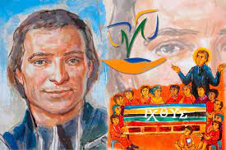
It is your work," he said to her; "you have brought us together, in spite of the obstacles that the world has put in our way, so that we may procure the glory of your divine Son; if you do not continue to help and sustain us, we will perish, we will be extinguished like a lamp that runs out of oil. But if this work perishes, it is not our work that dies, but yours, because you are the one who has given it life and sustained it until now; therefore, we count on your help at this critical moment, and we will always count on it".

PRAYER FOR VOCATIONS

Father, you call each of us by name and ask us to follow you. Bless your Church and give us dedicated and generous leaders of our families and friends who can serve your people as religious sisters, priests, deacons and lay ministers.
Inspire us as we grow in your love and open our hearts to hear your call. We ask this in Christ's name. Amen.

